|  |  |  |  |  |  |  |
| --- | --- | --- | --- | --- | --- | --- |
| **Document History** | | | | | | |
| **Document Name** | **Version** | **Status** | **Date** | **Viewable** | **Editable** | **Response** |
| Promotion Provider_SDD_0.1 | Promotion Provider_SDD_0.1  **Added**   * Chapter 1 | Introduction * Chapter 2 | System Architecture * Chapter 3 | Detail Design | Draft | 08-07-2015 | TS, NC, PS | TS, NC | NC |
| Promotion Provider_SDD_0.2 | Promotion Provider_SDD_0.2  **Added**   * Chapter 4 | User Interface | Draft | 12-07-2015 | TS, NC, PS | TS, NC | TS |
| Promotion Provider_SDD_0.3 | Promotion Provider_SDD_0.3  **Updated**   * Class Diagram | Draft | 23-07-2015 | TS, NC, PS | TS, NC | TS |
| Promotion Provider_SDD_1.0 | Promotion Provider_SDD_1.0  **Updated**   * User Interface | Approved | 25-07-2015 | TS, NC, PS | TS, NC | TS |
| Promotion Provider_SDD_1.1 | Promotion Provider_SDD_1.0  **Updated**   * Sequence diagram | Approved | 20-08-2015 | TS, NC, PS | TS, NC | TS |

Document Designed by

Tanawat Sitthitan  
Nattakit Chaiwongsri  
July 27, 2015   
  
Document Approved by

_______________   
Mr. Phudinan Singkhamfu

August 28, 2015

Content

List of Figure 5

List of Table 7

**Chapter 1 | Introduction** 8

1.1 Purpose 8

1.2 Project Scope 8

1.3 Definition, Acronyms, and Abbreviation 8

1.3.1 Key definition 8

1.3.2 Keys Acronyms and Abbreviations 9

1.4 User Characteristic 9

**Chapter 2 | System Architecture** 11

**Chapter 3 | Detailed Design** 12

3.1 Class diagram 12

3.1.1 Promotion provider class diagram 12

3.1.2 Promotion provider class diagram description 17

3.2 ER-Diagram 49

3.2.1 Accounts Table 51

3.2.2 ShopInformations Table 51

3.2.3 Logs Table 51

3.2.4 Promotions Table 51

3.2.5 ShopImage Table 52

3.2.6 PromotionImage Table 52

3.2.7 MobileUsers Table 52

3.2.8 RequestingSignup Table 52

3.2.9 Codes Table 53

3.3 Sequence Diagram 54

3.3.1 URS-01: Admin can login to web server 54

3.3.2 URS-02: Admin can logout from web server 55

3.3.3 URS-03: Admin can add shop owner account 56

3.3.4 URS-04: Admin can edit shop owner account 57

3.3.5 URS-05: Admin can delete shop owner account 58

3.3.6 URS-06: Admin can add promotion to shop owner 59

3.3.7 URS-07: Admin can edit shop owner promotion 60

3.3.8 URS-08: Admin can delete shop owner promotion 61

3.3.9 URS-09: Admin can accept register request 62

3.3.10 URS-10: Admin can reject register request 63

3.3.11 URS-11: Admin can view account list 64

3.3.12 URS-12: Admin can view account information 65

3.3.13 URS-13: Admin can view promotion list 66

3.3.14 URS-14: Admin can view promotion information 67

3.3.15 URS-15: Admin can view user logs 68

3.3.16 URS-16: Admin can view redeem code list 69

3.3.17 URS-17: Admin can view redeem code information 70

3.3.18 URS-18: Admin can view mobile user list 71

3.3.19 URS-19: Admin can view mobile user information 72

3.3.20 URS-20: Admin can search account by shop name 73

3.3.21 URS-21: Admin can search account by email 74

3.3.22 URS-22: Admin can search account by id 75

3.3.23 URS-23: Admin can search promotion by name 76

3.3.24 URS-24: Admin can search promotion by id 77

3.3.25 URS-25: Admin can search promotion by shop name 78

3.3.26 URS-26: Admin can search logs by function 79

3.3.27 URS-27: Admin can search logs by shop name 80

3.3.28 URS-28: Admin can search logs by email 81

3.3.29 URS-29: Admin can change password 82

3.3.30 URS-30: Shop owner can add promotion 83

3.3.31 URS-31: Shop owner can edit promotion 84

3.3.32 URS-32: Shop owner can delete promotion 85

3.3.33 URS-33: Shop owner can update their profile 86

3.3.34 URS-34: Shop owner can change password 87

3.3.35 URS-35: Shop owner can login to system 88

3.3.36 URS-36: Shop owner can logout 89

3.3.38 URS-38: Shop owner can view promotion list 90

3.3.39 URS-39: Shop owner can view promotion information 91

3.3.40 URS-40: Guest can sent register request 92

**Chapter 4 | User Interface Design** 93

1. Index page 93

2. Promotion list page 94

3. Account list page 95

4. Request list page 96

5. Add promotion page 97

6. Add account page 98

7. Promotion information page 99

8. Account information page 100

9. Home page 101

# List of Figure

|  |  |
| --- | --- |
| Figure 4.1: System Architecture…………………………………………………………………………………………… | 11 |
| Figure 4.2: Overall Promotion provider class diagram (1) ……………………………………………………. | 12 |
| Figure 4.3: Overall Promotion provider class diagram (2) ……………………………………………………. | 13 |
| Figure 4.4: Dao package class diagram………………………………………………………………………………… | 14 |
| Figure 4.5: Controller class diagram…………………………………………………………………………………….. | 15 |
| Figure 4.6: Entity package class diagram……………………………………………………………………………… | 16 |
| Figure 4.7: AccountInfo Class………………………………………………………………………………………………. | 17 |
| Figure 4.8: ShopInformation Class……………………………………………………………………………………….. | 18 |
| Figure 4.9: ShopImage Class………………………………………………………………………………………………… | 20 |
| Figure 4.10: Promotion Class……………………………………………………………………………………………….. | 21 |
| Figure 4.11: ActivitiesLog Class……………………………………………………………………………………………. | 23 |
| Figure 4.12: RequestSignupInfo Class………………………………………………………………………………….. | 25 |
| Figure 4.13: PromotionImage Class……………………………………………………………………………………… | 28 |
| Figure 4.14: AccountDao Class…………………………………………………………………………………………….. | 29 |
| Figure 4.15: AccountDaoImpl Class……………………………………………………………………………………… | 30 |
| Figure 4.16: RequestSignupInfoDao Class……………………………………………………………………………. | 31 |
| Figure 4.17: RequestSignupInfoDaoImpl Class……………………………………………………………………… | 32 |
| Figure 4.18: ActivitiesLogDao Class……………………………………………………………………………………… | 33 |
| Figure 4.19: ActivitiesLogsDaoImpl Class……………………………………………………………………………… | 34 |
| Figure 4.20: PromtoionImageDao Class……………………………………………………………………………….. | 35 |
| Figure 4.21: PromotionImageDaoImpl Class………………………………………………………………………… | 36 |
| Figure 4.22: PromotionDao Class…………………………………………………………………………………………. | 37 |
| Figure 4.23: PromotionDaoImpl Class………………………………………………………………………………….. | 38 |
| Figure 4.24: ShopImageDao Class………………………………………………………………………………………… | 39 |
| Figure 4.25: ShopImageDaoImpl Class…………………………………………………………………………………. | 40 |
| Figure 4.26: ShopInformationDao Class……………………………………………………………………………….. | 41 |
| Figure 4.27: ShopInformationDaoImpl Class………………………………………………………………………… | 42 |
| Figure 4.28: AccountController Class…………………………………………………………………………………… | 43 |
| Figure 4.29: ShopImageController Class………………………………………………………………………………. | 44 |
| Figure 4.30: PromotionImageController Class……………………………………………………………………… | 45 |
| Figure 4.31: PromotionController Class……………………………………………………………………………….. | 46 |
| Figure 4.32: ActivitiesLogsController Class…………………………………………………………………………… | 47 |
| Figure 4.33: RequestSignupController Class…………………………………………………………………………. | 48 |
| Figure 4.34: ShopInformationController Class……………………………………………………………………… | 49 |
| Figure 4.35: ER - Diagram…………………………………………………………………………………………………….. | 50 |
| Figure 4.36: SD-01 Admin can login to web server sequence diagram…………………………………. | 54 |
| Figure 4.37: SD-02 Admin can logout from web server sequence diagram…………………………… | 55 |
| Figure 4.38: SD-03 Admin can add shop owner account sequence diagram………………………… | 56 |
| Figure 4.39: SD-04 Admin can edit shop owner account sequence diagram………………………… | 57 |
| Figure 4.40: SD-05 Admin can delete shop owner account sequence diagram…………………….. | 58 |
| Figure 4.41: SD-06 Admin can add promotion to shop owner sequence diagram………………… | 59 |
| Figure 4.42: SD-07 Admin can edit shop owner promotion sequence diagram……………………. | 60 |
| Figure 4.43: SD-08 Admin can delete shop owner promotion sequence diagram………………… | 61 |
| Figure 4.44: SD-09 Admin can accept register request sequence diagram…………………………… | 62 |
| Figure 4.45: SD-10 Admin can reject register request sequence diagram…………………………….. | 63 |
| Figure 4.46: SD-11 Admin can view account list sequence diagram…………………………………….. | 64 |
| Figure 4.47: SD-12 Admin can view account information sequence diagram……………………….. | 65 |
| Figure 4.48: SD-13 Admin can view promotion list sequence diagram…………………………………. | 66 |
| Figure 4.49: SD-14 Admin can view promotion information sequence diagram…………………… | 67 |
| Figure 4.50: SD-15 Admin can view user logs sequence diagram…………………………………………. | 68 |
| Figure 4.51: SD-16 Admin can view redeem code list sequence diagram…………………………….. | 69 |
| Figure 4.52: SD-17 Admin can view redeem code information sequence diagram………………. | 70 |
| Figure 4.53: SD-18 Admin can view mobile user list sequence diagram……………………………….. | 71 |
| Figure 4.54: SD-19 Admin can view mobile user information sequence diagram…………………. | 72 |
| Figure 4.55: SD-20 Admin can search account by shop name sequence diagram…………………. | 73 |
| Figure 4.56: SD-21 Admin can search account by email sequence diagram…………………………. | 74 |
| Figure 4.57: SD-22 Admin can search account by id sequence diagram……………………………….. | 75 |
| Figure 4.58: SD-23 Admin can search promotion by name sequence diagram…………………….. | 76 |
| Figure 4.59: SD-24 Admin can search promotion by id sequence diagram…………………………… | 77 |
| Figure 4.60: SD-25 Admin can search promotion by shop name sequence diagram…………….. | 78 |
| Figure 4.61: SD-26 Admin can search logs by function sequence diagram…………………………… | 79 |
| Figure 4.62: SD-27 Admin can search logs by shop name sequence diagram……………………….. | 80 |
| Figure 4.63: SD-28 Admin can search logs by email sequence diagram……………………………….. | 81 |
| Figure 4.64: SD-29 Admin can change password sequence diagram……………………………………. | 82 |
| Figure 4.65: SD-30 Shop owner can add promotion sequence diagram……………………………….. | 83 |
| Figure 4.66: SD-31 Shop owner can edit promotion sequence diagram………………………………. | 84 |
| Figure 4.67: SD-32 Shop owner can delete promotion sequence diagram…………………………… | 85 |
| Figure 4.68: SD-33 Shop owner can update their profile sequence diagram………………………… | 86 |
| Figure 4.69: SD-34 Shop owner can change password sequence diagram……………………………. | 87 |
| Figure 4.70: SD-35 Shop owner can log in to system sequence diagram………………………………. | 88 |
| Figure 4.71: SD-36 Shop owner can logout sequence diagram…………………………………………….. | 89 |
| Figure 4.72: SD-38 Shop owner can view promotion list sequence diagram………………………… | 90 |
| Figure 4.73: SD-39 Shop owner can view promotion information sequence diagram………….. | 91 |
| Figure 4.74: SD-40 Guest can sent register request sequence diagram………………………………… | 92 |
| Figure 4.75: Index page……………………………………………………………………………………………………….. | 93 |
| Figure 4.76: Promotion list page………………………………………………………………………………………….. | 94 |
| Figure 4.77: Account list page……………………………………………………………………………………………… | 95 |
| Figure 4.78: Request list page……………………………………………………………………………………………… | 96 |
| Figure 4.79: Add promotion page………………………………………………………………………………………… | 97 |
| Figure 4.80: Add account page…………………………………………………………………………………………….. | 98 |
| Figure 4.81: Promotion information page……………………………………………………………………………. | 99 |
| Figure 4.82: Account information page……………………………………………………………………………….. | 100 |
| Figure 4.83: Home page………………………………………………………………………………………………………. | 101 |

# List of Table

|  |  |
| --- | --- |
| Table 4.1: Key Acronyms and Abbreviations………………………………………………………………………… | 8 |
| Table 4.2: AccountInfo Class Description……………………………………………………………………………… | 16 |
| Table 4.3: ShopInformation Class Description……………………………………………………………………… | 18 |
| Table 4.4: ShopImage Class Description………………………………………………………………………………. | 20 |
| Table 4.5: Promotion Class Diagram……………………………………………………………………………………. | 21 |
| Table 4.6: ActivitiesLog Class Description…………………………………………………………………………….. | 23 |
| Table 4.7: RequesstSignupInfo Class Description…………………………………………………………………. | 25 |
| Table 4.8: PromotionImage Class Description……………………………………………………………………… | 28 |
| Table 4.9: AccountDao Class Description……………………………………………………………………………… | 29 |
| Table 4.10: AccountDaoImpl Class Description……………………………………………………………………. | 30 |
| Table 4.11: RequestSignupInfoDao Class Description…………………………………………………………… | 31 |
| Table 4.12: RequestSignupInfoDaoImpl Class Description……………………………………………………. | 32 |
| Table 4.13: ActivitiesLogDao Class Description……………………………………………………………………. | 33 |
| Table 4.14: ActivitiesLogsDaoImpl Class Description……………………………………………………………. | 34 |
| Table 4.15: PromotionImageDao Class Description……………………………………………………………… | 35 |
| Table 4.16: PromotionImageDaoImpl Class Description………………………………………………………. | 36 |
| Table 4.17: PromotionDao Class Description……………………………………………………………………….. | 37 |
| Table 4.18: PromotionDaoImpl Class Description………………………………………………………………… | 38 |
| Table 4.19: ShopImageDao Class Description………………………………………………………………………. | 39 |
| Table 4.20: ShopImageDaoImpl Class Description……………………………………………………………….. | 40 |
| Table 4.21: ShopInformationDao Class Description……………………………………………………………… | 41 |
| Table 4.22: ShopInformationDaoImpl Class Description………………………………………………………. | 42 |
| Table 4.23: AccountController Class Description…………………………………………………………………. | 43 |
| Table 4.24: ShopImageController Class Description…………………………………………………………….. | 44 |
| Table 4.25: PromotionImageController Class Description……………………………………………………. | 45 |
| Table 4.26: PromotionController Class Description……………………………………………………………… | 46 |
| Table 4.27: ActivitiesLogsController Class Description………………………………………………………… | 47 |
| Table 4.28: RequestSignupController Class Description……………………………………………………….. | 48 |
| Table 4.29: ShopInformationController Class Description……………………………………………………. | 49 |
| Table 4.30: Accounts Table………………………………………………………………………………………………….. | 51 |
| Table 4.31: ShopInformations Table……………………………………………………………………………………. | 51 |
| Table 4.32: Logs Table…………………………………………………………………………………………………………. | 51 |
| Table 4.33: Promotions Table………………………………………………………………………………………………. | 51 |
| Table 4.34: ShopImage Table………………………………………………………………………………………………. | 52 |
| Table 4.35: PromotionImage Table……………………………………………………………………………………… | 52 |
| Table 4.36: MobileUsers Table…………………………………………………………………………………………….. | 52 |
| Table 4.37: RequestingSignup Table……………………………………………………………………………………. | 52 |
| Table 4.38: Codes Table………………………………………………………………………………………………………. | 53 |

# Chapter 1 | Introduction

## 1.1 Purpose

The Software Design Document (SDD) is a document to provide documentation, which will be used to aid in software development by providing the detail of how the software should be built. In the Software Design Document is narrative and graphical documentation of the software design for this project.

## This document contains design description of the promotion provider. This includes the architectural feature of the system down though the detail of what operations will perform. It also shows how the use cases promised in the SRS would be implementation in the system using this design.

## 1.2 Project Scope

## This Software Design Document provides a description of the design of the promotion provider. The dominant design methodology is an object-oriented design combine with Model-View-Controller.

## This Software Design Document is for a high-level system, which will work as a proof of the concepts. This software design is focused on the high-level system and critical parts of the system.

## 1.3 Definition, Acronyms, and Abbreviation

### 1.3.1 Key definition

|  |  |
| --- | --- |
| **Design** | “The period of time in the software lift cycle during which the design for architect, software components, interfaces, and data are created, and verified to satisfy requirement.”[IEEE90] |
| **Entity Relationship**  **Diagram** | “data modeling technique that creates a graphical representation of the entities, and the relationships between entities, within an information system.”  [techtarget.com] |
| **iOS** | “the operating system in the iPhone and iPod touch. ” |
| **System Architecture** | “a generic discipline to handle objects (existing or to be created) called "systems", in a way that supports reasoning about the structural properties of these objects.”  [Lix.polytechnique.fr] |
| **Client** | “a client is an application that runs on a personal computer or workstation and relies on a server to perform some operations. For example, an *e-mail client* is an application that enables you to send and receive e-mail.” |

### 1.3.2 Keys Acronyms and Abbreviations

|  |  |
| --- | --- |
| **Key Acronyms** | **Abbreviation** |
| SRS | System Requirement Specification |
| SDD | Software Design Document |
| ERD | Entity Relationship Diagram |
| GUI | Graphic User Interface |
| SD | Sequence Diagram |

Table 4.: Key Acronyms and Abbreviations

## 1.4 User Characteristic

Administrator should be able to:

* Login to web application
* Logout from web application
* Add shop owner account
* View shop owner account
* Delete shop owner account
* Add promotion
* Edit promotion
* Delete promotion
* Accept register request
* Reject Register request

Shop owner should be able to:

* Login to web application
* Logout from web application
* Add promotion
* Edit promotion
* Delete promotion
* Update profile
* Change password

Guest should be able to:

* Sent register request

# Chapter 2 | System Architecture

Figure 4.: System Architecture

This project will have two sides, the first is client side that is the iPhone application. The client will use Apple API to provide a map. The second is server side that is web and database. In this system client need to connect a server, and then the server will connect to the database and sent the data back to the client via the Internet in the form of JSON. The client application cannot retrieve information without connecting to the server because every data and information of the restaurant of the hotel will store in the database server. User (Hotel or restaurant) can add promotions into our system, and admin can also manage data in the system that are adding, editing and deleting.

# Chapter 3 | Detailed Design

## 3.1 Class diagram

### 3.1.1 Promotion provider class diagram

#### 3.1.1.1 Overall Promotion provider class diagram

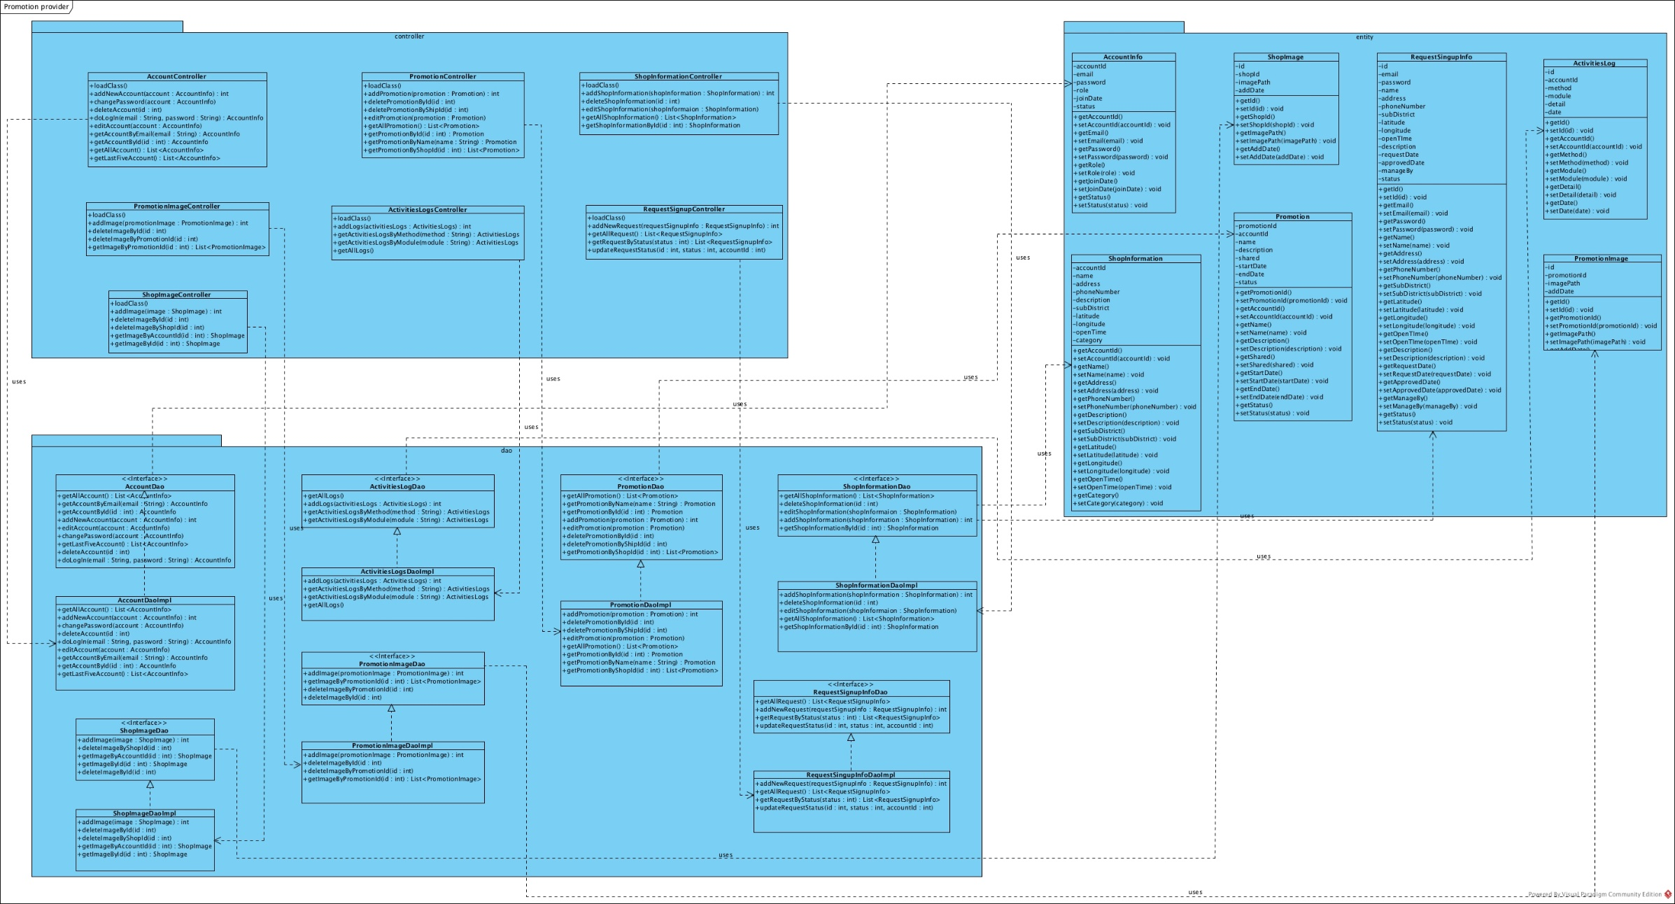

Figure 4.2: Overall Promotion provider class diagram (1)

#### 

Figure 4.: Overall Promotion provider class diagram (2)

#### 3.1.1.2 Dao package class diagram

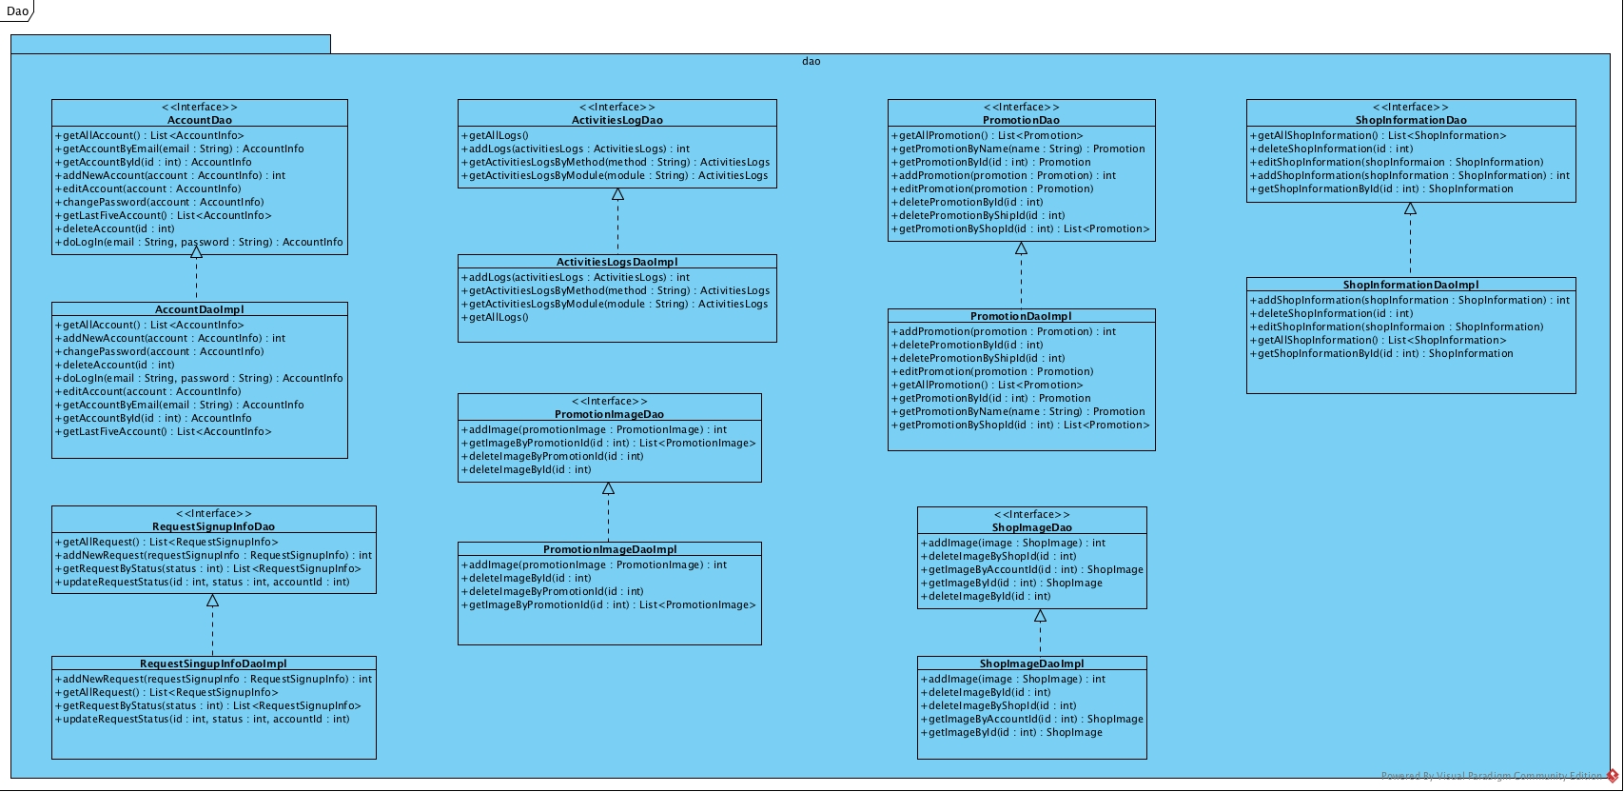

Figure 4.: Dao package class diagram

#### 3.1.1.3 Controller package class diagram

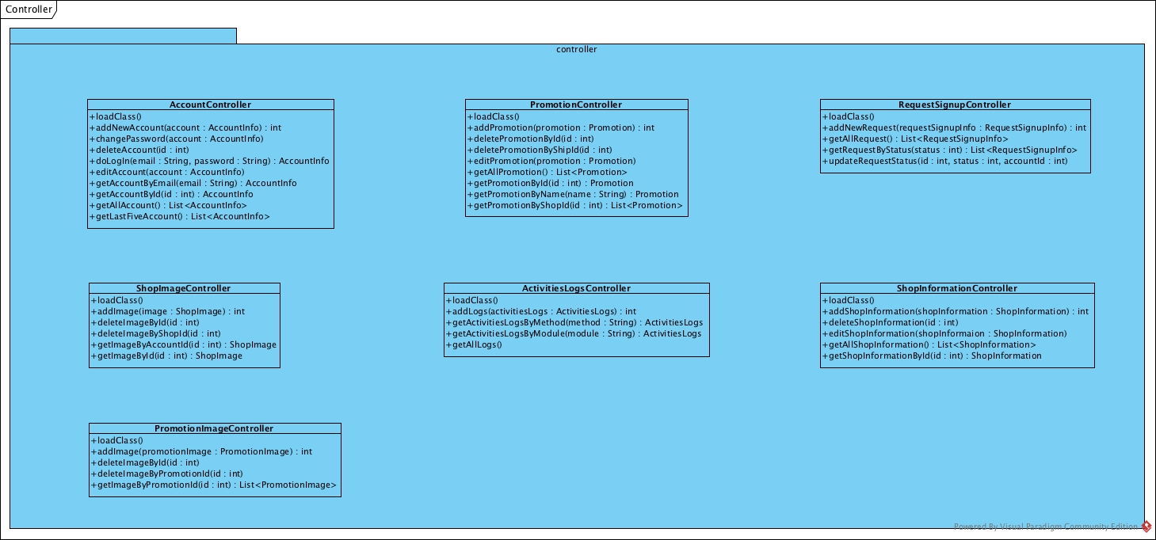

Figure 4.: Controller class diagram

#### 3.1.1.4 Entity package class diagram

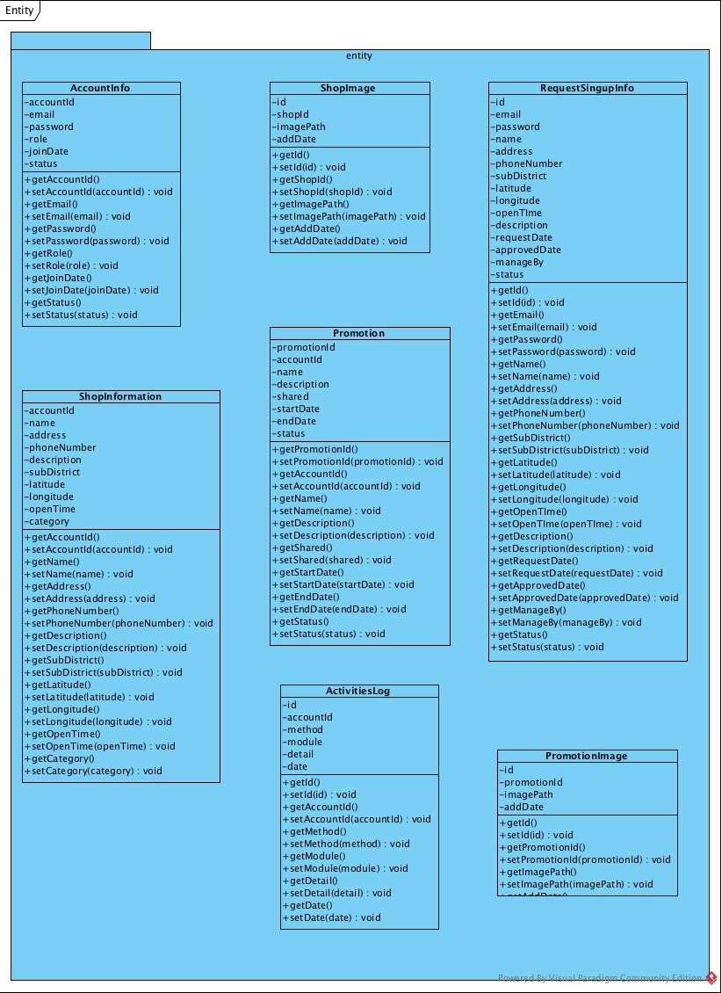

Figure 4.: Entity package class diagram

### 3.1.2 Promotion provider class diagram description

1. Class name: AccountInfo



Figure 4.: AccountInfo Class

|  |  |  |
| --- | --- | --- |
| **Field Name** | **Description** | **Remark** |
| accountId | Account Id | Type: int |
| email | Email | Type: String |
| password | Password | Type: String |
| role | Role of user | Type: String |
| joinDate | Join Date | Type: Datetime |
| status | Status of user | Type: int |
|  |  |  |
| **Method Name** | **Description** | **Remark** |
| getAccountId() | Method for getting attribute name accountId |  |
| setAccountId(accountId) | Method for setting attribute name accountId | Return Type: void |
| getEmail() | Method for getting attribute name email |  |
| setEmail(email) | Method for setting attribute name email | Return Type: void |
| getPassword() | Method for getting attribute name password |  |
| setPassword(password) | Method for setting attribute name password | Return Type: void |
| getRole() | Method for getting attribute name role |  |
| setRole(role) | Method for setting attribute name role | Return Type: void |
| getJoinDate() | Method for getting attribute name joinDate |  |
| setJoinDate(joinDate) | Method for setting attribute name joinDate | Return Type: void |
| getStatus() | Method for getting attribute name status |  |
| setStuats(status) | Method for setting attribute name status | Return Type: void |

Table 4.: AccountInfo Class Description

1. Class name: ShopInformation



Figure 4.8: ShopInformation Class

|  |  |  |
| --- | --- | --- |
| **Field Name** | **Description** | **Remark** |
| accountId | Account Id | Type: int |
| name | Shop Name | Type: String |
| address | Shop address | Type: String |
| phoneNumber | Shop phone number | Type: String |
| description | Shop description | Type: String |
| subDistrict | Shop sub district | Type: String |
| latitude | Latitude | Type: decimal |
| longitude | Longitude | Type: decimal |
| openTime | Shop open time | Type: Datetime |
| category | Shop category | Type: String |
|  |  |  |
| **Method Name** | **Description** | **Remark** |
| getAccountId() | Method for getting attribute name accountId |  |
| setAccountId(accountId) | Method for setting attribute name accountId | Return Type: void |
| getName() | Method for getting attribute name name |  |
| setName(name) | Method for setting attribute name name | Return Type: void |
| getAddress() | Method for getting attribute name adress |  |
| setAddress (address) | Method for setting attribute name address | Return Type: void |
| getPhoneNumber() | Method for getting attribute name phoneNumber |  |
| setPhoneNumber(phoneNumber) | Method for setting attribute name phoneNumber | Return Type: void |
| getDescription() | Method for getting attribute name description |  |
| setDescription(description) | Method for setting attribute name description | Return Type: void |
| getSubDistrict() | Method for getting attribute name subDistrict |  |
| setSubDistrict(subDistrict) | Method for setting attribute name subDistrict | Return Type: void |
| getLatitude() | Method for getting attribute name latitude |  |
| setLatitude(latitude) | Method for setting attribute name latitude | Return Type: void |
| getLongitude() | Method for getting attribute name logitude |  |
| setLongitude(logitude) | Method for setting attribute name logitude | Return Type: void |
| getOpenTime() | Method for getting attribute name openTime |  |
| setOpenTime(openTime) | Method for setting attribute name openTime | Return Type: void |
| getCategory() | Method for getting attribute name category |  |
| setCategory(category) | Method for setting attribute name category | Return Type: void |

Table 4.: ShopInformation Class Description

1. Class name: ShopImage



Figure 4.: ShopImage Class

|  |  |  |
| --- | --- | --- |
| **Field Name** | **Description** | **Remark** |
| id | Image Id | Type: int |
| shopId | Shop Id | Type: int |
| imagePath | Image Path | Type: String |
| addDate | Add Date | Type: Datetime |
|  |  |  |
| **Method Name** | **Description** | **Remark** |
| getId() | Method for getting attribute name id |  |
| setId(id) | Method for setting attribute name id | Return Type: void |
| getShopId() | Method for getting attribute name shopId |  |
| setShopId(shopId) | Method for setting attribute name shopId | Return Type: void |
| getImagePath() | Method for getting attribute name imagePath |  |
| setImagePath(imagePath) | Method for setting attribute name imagePath | Return Type: void |
| getAddDate() | Method for getting attribute name addDate |  |
| setAddDate(addDate) | Method for setting attribute name addDate | Return Type: void |

Table 4.: ShopImage Class Description

1. Class name: Promotion



Figure 4.: Promotion Class

|  |  |  |
| --- | --- | --- |
| **Field Name** | **Description** | **Remark** |
| promotionId | Promotion Id | Type: int |
| accountId | Account Id | Type: int |
| name | Promotion name | Type: String |
| description | Promotion description | Type: String |
| shared | Amount of shared promotion | Type: int |
| startDate | Date of start promotion | Type: Datetime |
| endDate | Date of end promotion | Type: Datetime |
| status | Status of promotion | Type: int |
|  |  |  |
| **Method Name** | **Description** | **Remark** |
| getPromotionId() | Method for getting attribute name promotionId |  |
| setPromotionId(promotionId) | Method for setting attribute name promotionId | Return Type: void |
| getAccountId() | Method for getting attribute name accountId |  |
| setAccountId(accountId) | Method for setting attribute name accountId | Return Type: void |
| getName() | Method for getting attribute name name |  |
| setName(name) | Method for setting attribute name name | Return Type: void |
| getDescription() | Method for getting attribute name description |  |
| setDescription(description) | Method for setting attribute name description | Return Type: void |
| getShared() | Method for getting attribute name shared |  |
| setShared(shared) | Method for setting attribute name shared | Return Type: void |
| getStartDate() | Method for getting attribute name startDate |  |
| setStartDate(startDate) | Method for setting attribute name startDate | Return Type: void |
| getEndDate() | Method for getting attribute name endDate |  |
| setEndDate(startDate) | Method for setting attribute name endDate | Return Type: void |
| getStatus() | Method for getting attribute name status |  |
| setStatus(status) | Method for setting attribute name satus | Return Type: void |

Table 4.: Promotion Class Description

1. Class name: ActivitiesLog



Figure 4.: ActivitiesLog Class

|  |  |  |
| --- | --- | --- |
| **Field Name** | **Description** | **Remark** |
| id | Activities logs Id | Type: int |
| accountId | Account Id | Type: int |
| method | Method name | Type: String |
| module | Module name | Type: String |
| detail | Activities logs detail | Type: String |
| date | Date | Type: Datetime |
|  |  |  |
| **Method Name** | **Description** | **Remark** |
| getId() | Method for getting attribute name Id |  |
| setId(Id) | Method for setting attribute name Id | Return Type: void |
| getAccountId() | Method for getting attribute name accountId |  |
| setAccountId(accountId) | Method for setting attribute name accountId | Return Type: void |
| getMethod () | Method for getting attribute name method |  |
| setMethod(method) | Method for setting attribute name method | Return Type: void |
| getModule() | Method for getting attribute name module |  |
| setModule(module) | Method for setting attribute name module | Return Type: void |
| getDetail() | Method for getting attribute name detail |  |
| setDetail(detail) | Method for setting attribute name detail | Return Type: void |
| getDate() | Method for getting attribute name date |  |
| setDate(Date) | Method for setting attribute name date | Return Type: void |

Table 4.: ActivitiesLog Class Description

1. Class name: RequestSignupInfo



Figure 4.: RequestSignupInfo Class

|  |  |  |
| --- | --- | --- |
| **Field Name** | **Description** | **Remark** |
| id | Id | Type: int |
| email | Email | Type: String |
| password | Password | Type: String |
| name | Name | Type: String |
| address | Address | Type: String |
| phoneNumber | Shop phone number | Type: String |
| subDistrict | Shop sub district | Type: String |
| latitude | Latitude | Type: decimal |
| longitude | Longitude | Type: decimal |
| openTime | Shop open time | Type: Datetime |
| description | Shop description | Type: String |
| requestDate | Request sign up date | Type: Datetime |
| approvedDate | Approved sign up date | Type: Datetime |
| manageBy | Who approve or reject sign up request | Type: int |
| status | Status of sign up request | Type: int |
|  |  |  |
| **Method Name** | **Description** | **Remark** |
| getId() | Method for getting attribute name id |  |
| setId(id) | Method for setting attribute name id | Return Type: void |
| getEmail() | Method for getting attribute name email |  |
| setEmail(email) | Method for setting attribute name email | Return Type: void |
| getPassword() | Method for getting attribute name password |  |
| setPassword(password) | Method for setting attribute name password | Return Type: void |
| getName() | Method for getting attribute name name |  |
| setName(name) | Method for setting attribute name name | Return Type: void |
| getAddress() | Method for getting attribute name adress |  |
| setAddress (address) | Method for setting attribute name address | Return Type: void |
| getPhoneNumber() | Method for getting attribute name phoneNumber |  |
| setPhoneNumber(phoneNumber) | Method for setting attribute name phoneNumber | Return Type: void |
| getSubDistrict() | Method for getting attribute name subDistrict |  |
| setSubDistrict(subDistrict) | Method for setting attribute name subDistrict | Return Type: void |
| getLatitude() | Method for getting attribute name latitude |  |
| setLatitude(latitude) | Method for setting attribute name latitude | Return Type: void |
| getLongitude() | Method for getting attribute name logitude |  |
| setLongitude(logitude) | Method for setting attribute name logitude | Return Type: void |
| getOpenTime() | Method for getting attribute name openTime |  |
| setOpenTime(openTime) | Method for setting attribute name openTime | Return Type: void |
| getDescription() | Method for getting attribute name description |  |
| setDescription(description) | Method for setting attribute name description | Return Type: void |
| getRequestDate() | Method for getting attribute name requestDate |  |
| setRequestDate(requestDate) | Method for setting attribute name requestDate | Return Type: void |
| getApprovedDate() | Method for getting attribute name approvedDate |  |
| setApprovedDate(approvedDate) | Method for setting attribute name ApprovedDate | Return Type: void |
| getManageBy() | Method for getting attribute name manageBy |  |
| setManageBy(manageBy) | Method for setting attribute name manageBy | Return Type: void |
| getStatus() | Method for getting attribute name status |  |
| setStatus(status) | Method for setting attribute name status | Return Type: void |

Table 4.: RequesstSignupInfo Class Description

1. Class name: PromotionImage



Figure 4.: PromotionImage Class

|  |  |  |
| --- | --- | --- |
| **Field Name** | **Description** | **Remark** |
| id | Promotion image Id | Type: int |
| promotionId | Promotion Id | Type: int |
| imagePath | Image path | Type: String |
| addDate | Add date | Type: String |
|  |  |  |
| **Method Name** | **Description** | **Remark** |
| getId() | Method for getting attribute name id |  |
| setId(Id) | Method for setting attribute name id | Return Type: void |
| getPromotionId() | Method for getting attribute name promotionId |  |
| setPromotionId(promotionId) | Method for setting attribute name promotionId | Return Type: void |
| getImagePath() | Method for getting attribute name imagePath |  |
| setimagePath(imagePath) | Method for setting attribute name imagePath | Return Type: void |
| getAddDate() | Method for getting attribute name addDate |  |
| setAddDate(addDate) | Method for setting attribute name addDate | Return Type: void |

Table 4.: PromotionImage Class Description

1. Class name: AccountDao



Figure 4.: AccountDao Class

|  |  |  |
| --- | --- | --- |
| **Field Name** | **Description** | **Remark** |
| - | - | - |
|  |  |  |
| **Method Name** | **Description** | **Remark** |
| getAllAccount() | Method for getting all account from database | Return Type: List<AccountInfo> |
| getAccountByEmail(email: String) | Method for getting account information from database by using email | Return Type: AccountInfo |
| getAccountById(id: int) | Method for getting account information from database by using account id | Return Type: AccountInfo |
| addNewAccount(account: AccountInfo) | Method for adding new account information into database | Return Type: int |
| editAccount(account: AccountInfo) | Method for edit account information into database |  |
| changePassword(account: AccountInfo) | Method for changing new password |  |
| getLastFiveAccount() | Method for getting latest five account in database | Return Type: List<AccountInfo> |
| deleteAccount(id: int) | Method for deleting account information from database by using account id |  |
| doLogIn(email: String, password: String) | Method for logging in to web server | Return Type: AccountInfo |

Table 4.: AccountDao Class Description

1. Class name: AccountDaoImpl



Figure 4.: AccountDaoImpl Class

|  |  |  |
| --- | --- | --- |
| **Field Name** | **Description** | **Remark** |
| - | - | - |
|  |  |  |
| **Method Name** | **Description** | **Remark** |
| getAllAccount() | Method for getting all account from database | Return Type: List<AccountInfo> |
| addNewAccount(account: AccountInfo) | Method for adding new account information into database | Return Type: int |
| changePassword(account: AccountInfo) | Method for changing new password |  |
| deleteAccount(id: int) | Method for deleting account information from database by using account id |  |
| doLogIn(email: String, password: String) | Method for logging in to web server | Return Type: AccountInfo |
| editAccount(account: AccountInfo) | Method for edit account information into database |  |
| getAccountByEmail(email: String) | Method for getting account information from database by using email | Return Type: AccountInfo |
| getAccountById(id: int) | Method for getting account information from database by using account id | Return Type: AccountInfo |
| getLastFiveAccount() | Method for getting latest five account in database | Return Type: List<AccountInfo> |

Table 4.: AccountDaoImpl Class Description

1. Class name: RequestSignupInfoDao



Figure 4.: RequestSignupInfoDao Class

|  |  |  |
| --- | --- | --- |
| **Field Name** | **Description** | **Remark** |
| - | - | - |
|  |  |  |
| **Method Name** | **Description** | **Remark** |
| getAllRequest() | Method for getting all request sign up from database | Return Type: List<RequestSignupInfo> |
| addNewRequest(requestSignupInfo: RequestSignupInfo) | Method for adding new request sign up information into database | Return Type: int |
| getRequestByStatus(status: int) | Method for getting request sign up information from database by using status | Return Type: List<RequestSignupInfo> |
| updateRequestStatus(id: int, status: int, accountId: int) | Method for updating status of request sign up into database |  |

Table 4.: RequestSignupInfoDao Class Description

1. Class name: RequestSignupInfoDaoImpl



Figure 4.: RequestSignupInfoDaoImpl Class

|  |  |  |
| --- | --- | --- |
| **Field Name** | **Description** | **Remark** |
| - | - | - |
|  |  |  |
| **Method Name** | **Description** | **Remark** |
| addNewRequest(requestSignupInfo: RequestSignupInfo) | Method for adding new request sign up information into database | Return Type: int |
| getAllRequest() | Method for getting all request sign up from database | Return Type: List<RequestSignupInfo> |
| getRequestByStatus(status: int) | Method for getting request sign up information from database by using status | Return Type: List<RequestSignupInfo> |
| updateRequestStatus(id: int, status: int, accountId: int) | Method for updating status of request sign up into database |  |

Table 4.: RequestSignupInfoDaoImpl Class Description

1. Class name: ActivitiesLogDao



Figure 4.: ActivitiesLogDao Class

|  |  |  |
| --- | --- | --- |
| **Field Name** | **Description** | **Remark** |
| - | - | - |
|  |  |  |
| **Method Name** | **Description** | **Remark** |
| getAllLogs() | Method for getting all logs from database |  |
| addLogs(activitiesLogs: ActivitiesLogs) | Method for adding new logs information into database |  |
| getActivitiesLogsByMethod(method: String) | Method for getting activities logs by using method | Return Type: ActivitiesLogs |
| getActivitiesLogsByModule(module: String) | Method for getting activities logs by using module | Return Type: ActivitiesLogs |

Table 4.: ActivitiesLogDao Class Description

1. Class name: ActivitiesLogsDaoImpl



Figure 4.: ActivitiesLogsDaoImpl Class

|  |  |  |
| --- | --- | --- |
| **Field Name** | **Description** | **Remark** |
| - | - | - |
|  |  |  |
| **Method Name** | **Description** | **Remark** |
| addLogs(activitiesLogs: ActivitiesLogs) | Method for adding new logs information into database |  |
| getActivitiesLogsByMethod(method: String) | Method for getting activities logs by using method | Return Type: ActivitiesLogs |
| getActivitiesLogsByModule(module: String) | Method for getting activities logs by using module | Return Type: ActivitiesLogs |
| getAllLogs() | Method for getting all logs from database |  |

Table 4.: ActivitiesLogsDaoImpl Class Description

1. Class name: PromotionImageDao



Figure 4.: PromtoionImageDao Class

|  |  |  |
| --- | --- | --- |
| **Field Name** | **Description** | **Remark** |
| - | - | - |
|  |  |  |
| **Method Name** | **Description** | **Remark** |
| addImage(promotionImage: PromotionImage) | Method for adding new image promotion into database | Return Type: int |
| getImageByPromotionId(id: int) | Method for getting promotion image by using promotion id | Return Type: List<PromotionImage> |
| deleteImageByPromotionId(id: int) | Method for deleting promotion image by using promotion id |  |
| deleteImageById(id: int) | Method for deleting promotion image by using image id |  |

Table 4.: PromotionImageDao Class Description

1. Class name: PromotionImageDaoImpl



Figure 4.: PromotionImageDaoImpl Class

|  |  |  |
| --- | --- | --- |
| **Field Name** | **Description** | **Remark** |
| - | - | - |
|  |  |  |
| **Method Name** | **Description** | **Remark** |
| addImage(promotionImage: PromotionImage) | Method for adding new image promotion into database | Return Type: int |
| getImageByPromotionId(id: int) | Method for getting promotion image by using promotion id | Return Type: List<PromotionImage> |
| deleteImageByPromotionId(id: int) | Method for deleting promotion image by using promotion id |  |
| deleteImageById(id: int) | Method for deleting promotion image by using image id |  |

Table 4.: PromotionImageDaoImpl Class Description

1. Class name: PromotionDao



Figure 4.: PromotionDao Class

|  |  |  |
| --- | --- | --- |
| **Field Name** | **Description** | **Remark** |
| - | - | - |
|  |  |  |
| **Method Name** | **Description** | **Remark** |
| getAllPromotion() | Method for getting all promotion information from database | Return Type: List<Promotion> |
| getPromotionByName(name: String) | Method for getting promotion information from database by using promotion name | Return Type: Promotion |
| getPromotionById(id: int) | Method for getting promotion information from database by using promotion id | Return Type: Promotion |
| addPromotion(promotion: Promotion) | Method for adding new promotion information into database | Return Type: int |
| editPromotion(promotion: Promotion) | Method for editing new promotion information into database |  |
| deletePromotionById(id: int) | Method for deleting promotion information by using promotion id |  |
| deletePromotionByShopId(shopId: int) | Method for deleting promotion information by using shop id |  |
| getPromotionByShopId(id: int) | Method for getting promotion information by using shop id | Return Type: list<Promotion> |

Table 4.: PromotionDao Class Description

1. Class name: PromotionDaoImpl



Figure 4.: PromotionDaoImpl Class

|  |  |  |
| --- | --- | --- |
| **Field Name** | **Description** | **Remark** |
| - | - | - |
|  |  |  |
| **Method Name** | **Description** | **Remark** |
| addPromotion(promotion: Promotion) | Method for adding new promotion information into database | Return Type: int |
| deletePromotionById(id: int) | Method for deleting promotion information by using promotion id |  |
| deletePromotionByShopId(shopId: int) | Method for deleting promotion information by using shop id |  |
| editPromotion(promotion: Promotion) | Method for editing new promotion information into database |  |
| getAllPromotion() | Method for getting all promotion information from database | Return Type: List<Promotion> |
| getPromotionByName(name: String) | Method for getting promotion information from database by using promotion name | Return Type: Promotion |
| getPromotionById(id: int) | Method for getting promotion information from database by using promotion id | Return Type: Promotion |
| getPromotionByShopId(id: int) | Method for getting promotion information by using shop id | Return Type: list<Promotion> |

Table 4.: PromotionDaoImpl Class Description

1. Class name: ShopImageDao



Figure 4.: ShopImageDao Class

|  |  |  |
| --- | --- | --- |
| **Field Name** | **Description** | **Remark** |
| - | - | - |
|  |  |  |
| **Method Name** | **Description** | **Remark** |
| addImage(image: ShopImage) | Method for adding new shop image into database | Return Type: int |
| deleteImageByShopId(id: int) | Method for deleting shop image by using shop id |  |
| getImageByAccountId(id: int) | Method for getting shop image from database by using account id | Return Type: ShopImage |
| getImageById(id: int) | Method for getting shop image from database by using image id | Return Type: ShopImage |
| deleteImageById(id: int) | Method for deleting shop image by using image id |  |

Table 4.: ShopImageDao Class Description

1. Class name: ShopImageDaoImpl



Figure 4.: ShopImageDaoImpl Class

|  |  |  |
| --- | --- | --- |
| **Field Name** | **Description** | **Remark** |
| - | - | - |
|  |  |  |
| **Method Name** | **Description** | **Remark** |
| addImage(image: ShopImage) | Method for adding new shop image into database | Return Type: int |
| deleteImageById(id: int) | Method for deleting shop image by using image id |  |
| deleteImageByShopId(id: int) | Method for deleting shop image by using shop id |  |
| getImageByAccountId(id: int) | Method for getting shop image from database by using account id | Return Type: ShopImage |
| getImageById(id: int) | Method for getting shop image from database by using image id | Return Type: ShopImage |

Table 4.: ShopImageDaoImpl Class Description

1. Class name: ShopInformationDao



Figure 4.: ShopInformationDao Class

|  |  |  |
| --- | --- | --- |
| **Field Name** | **Description** | **Remark** |
| - | - | - |
|  |  |  |
| **Method Name** | **Description** | **Remark** |
| getAllShopInformation() | Method for getting all shop information from database | List<ShopInformation> |
| deleteShopInformation(id: int) | Method for deleting shop information by using shop id |  |
| editShopInformation(shopInformation: ShopInformation) | Method for editing shop information |  |
| addShopInformation(shopInformation: ShopInformation) | Method for adding new shop information into database | Return Type: int |
| getShopInformationById(id: int) | Method for getting shop information from database by using shop id | Return Type: ShopInformation |

Table 4.: ShopInformationDao Class Description

1. Class name: ShopInformationDaoImpl



Figure 4.: ShopInformationDaoImpl Class

|  |  |  |
| --- | --- | --- |
| **Field Name** | **Description** | **Remark** |
| - | - | - |
|  |  |  |
| **Method Name** | **Description** | **Remark** |
| addShopInformation(shopInformation: ShopInformation) | Method for adding new shop information into database | Return Type: int |
| deleteShopInformation(id: int) | Method for deleting shop information by using shop id |  |
| editShopInformation(shopInformation: ShopInformation) | Method for editing shop information |  |
| getAllShopInformation() | Method for getting all shop information from database | List<ShopInformation> |
| getShopInformationById(id: int) | Method for getting shop information from database by using shop id | Return Type: ShopInformation |

Table 4.: ShopInformationDaoImpl Class Description

1. Class name: AccountController



Figure 4.: AccountController Class

|  |  |  |
| --- | --- | --- |
| **Field Name** | **Description** | **Remark** |
| - | - | - |
|  |  |  |
| **Method Name** | **Description** | **Remark** |
| loadClass() | Method for initialize class |  |
| addNewAccount(account: AccountInfo) | Method for adding new account into database | Return Type: int |
| changePassword(account: AccountInfo) | Method for changing password |  |
| deleteAccount(id: int) | Method for deleting account from database |  |
| doLogIn(email: String, password: String) | Method for logging in to system | Return Type: AccountInfo |
| editAccount(account: AccountInfo) | Method for editing account information |  |
| getAccountByEmail(email: String) | Method for getting account information by using email | Return Type: AccountInfo |
| getAccountById(id: int) | Method for getting account information by using id | Return Type: AccountInfo |
| getAllAccount () | Method for getting all account information | Return Type: List<AccountInfo> |
| getLastFiveAccount () | Method for getting latest five account information | Return Type: List<AccountInfo> |

Table 4.: AccountController Class Description

1. Class name: ShopImageController



Figure 4.: ShopImageController Class

|  |  |  |
| --- | --- | --- |
| **Field Name** | **Description** | **Remark** |
| - | - | - |
|  |  |  |
| **Method Name** | **Description** | **Remark** |
| loadClass() | Method for initialize class |  |
| addImage(image: ShopImage) | Method for adding new shop image into database | Return Type: int |
| deleteImageById(id: int) | Method for deleting shop image from database by using id |  |
| deleteImageByShopId(id: int) | Method for deleting shop image from database by using shop id |  |
| getImageByAccountId(id: int) | Method for getting shop image by using account id | Return Type: ShopImage |
| getImageById(id: int) | Method for getting shop image by using id | Return Type: ShopImage |

Table 4.: ShopImageController Class Description

1. Class name: PromotionImageController



Figure 4.: PromotionImageController Class

|  |  |  |
| --- | --- | --- |
| **Field Name** | **Description** | **Remark** |
| - | - | - |
|  |  |  |
| **Method Name** | **Description** | **Remark** |
| loadClass() | Method for initialize class |  |
| addImage(promotionImage: PromotionImage) | Method for adding new promotion image into database | Return Type: int |
| deleteImageById(id: int) | Method for deleting promotion image from database by using id |  |
| deleteImageByPromotionId(id: int) | Method for deleting promotion image from database by using promotion id |  |
| getImageByPromotionId(id: int) | Method for getting promotion image by using promotion id | Return Type: List<PromotionImage> |

Table 4.: PromotionImageController Class Description

1. Class name: PromotionController



Figure 4.: PromotionController Class

|  |  |  |
| --- | --- | --- |
| **Field Name** | **Description** | **Remark** |
| - | - | - |
|  |  |  |
| **Method Name** | **Description** | **Remark** |
| loadClass() | Method for initialize class |  |
| addPromotion(promotionImage: PromotionImage) | Method for adding new promotion into database | Return Type: int |
| deletePromotionById(id: int) | Method for deleting promotion from database by using id |  |
| deletePromotionByShopId(id: int) | Method for deleting promotion from database by using shop id |  |
| editPromotion(promotion: Promotion) | Method for editing promotion information |  |
| getAllPromotion() | Method for getting all promotion | Return Type: List<Promotion> |
| getPromotionById(id: int) | Method for getting promotion information from database by using promotion id | Return Type: Promotion |
| getPromotionByName(name: String) | Method for getting promotion information from database by using promotion name | Return Type: Promotion |
| getPromotionByShopId(id: int) | Method for getting promotion information from database by using shop id | Return Type: Promotion |

Table 4.: PromotionController Class Description

1. Class name: ActivitiesLogsController



Figure 4.: ActivitiesLogsController Class

|  |  |  |
| --- | --- | --- |
| **Field Name** | **Description** | **Remark** |
| - | - | - |
|  |  |  |
| **Method Name** | **Description** | **Remark** |
| loadClass() | Method for initialize class |  |
| addLogs(activitiesLogs: ActivitiesLogs) | Method for adding new activities logs into database | Return Type: int |
| getActivitiesLogsByMethod(method: String) | Method for getting activities logs information from database by using method name | Return Type: ActivitiesLogs |
| getActivitiesLogsByModule(module: String) | Method for getting activities logs information from database by using module name | Return Type: ActivitiesLogs |
| getAllLogs() | Method for getting all activities logs | Return Type: List<ActivitiesLogs> |

Table 4.: ActivitiesLogsController Class Description

1. Class name: RequestSignupController



Figure 4.: RequestSignupController Class

|  |  |  |
| --- | --- | --- |
| **Field Name** | **Description** | **Remark** |
| - | - | - |
|  |  |  |
| **Method Name** | **Description** | **Remark** |
| loadClass() | Method for initialize class |  |
| addNewRequest(requestSignupInfo: RequestSignupInfo) | Method for adding new request sign up information into database | Return Type: int |
| getAllRequest() | Method for getting all request sign up information from database | Return Type: List<RequestSignupInfo> |
| getRequestBystatus(status: int) | Method for getting request sign up information from database by using status | Return Type: List<RequestSignupInfo> |
| updateRequestStatus(id: int, status: int, accountId: int) | Method for getting update status of request sign up |  |

Table 4.: RequestSignupController Class Description

1. Class name: ShopInformationController



Figure 4.: ShopInformationController Class

|  |  |  |
| --- | --- | --- |
| **Field Name** | **Description** | **Remark** |
| - | - | - |
|  |  |  |
| **Method Name** | **Description** | **Remark** |
| loadClass() | Method for initialize class |  |
| addShopInformation(shopInformation: ShopInformation) | Method for adding new shop information into database | Return Type: int |
| deleteShopInformation(id: int) | Method for deleting shop information from database |  |
| editShopInformation(shopInformation: ShopInformation) | Method for editing shop information |  |
| getAllShopInformation() | Method for getting all shop information from database | Return Type: List<ShopInformation> |
| getShopInformationById(id: int) | Method for getting shop information from database by using shop id | Return Type: ShopInformation |

Table 4.: ShopInformationController Class Description

## 3.2 ER-Diagram

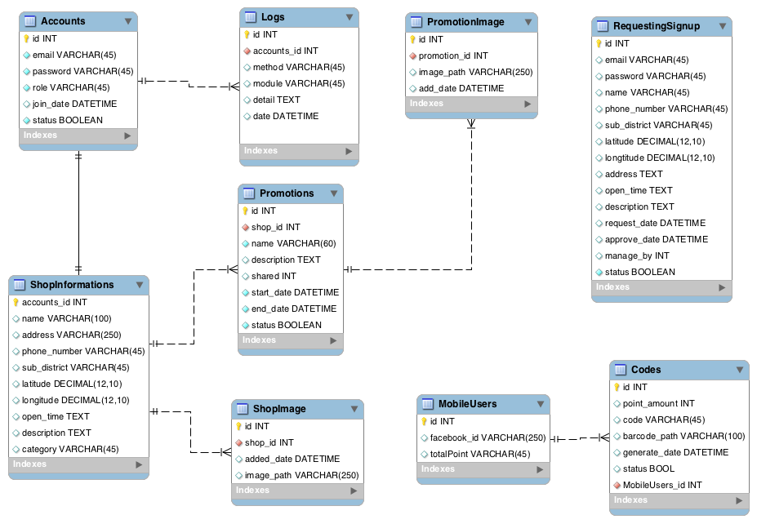

Figure 4.35: ER - Diagram

### 3.2.1 Accounts Table

|  |  |  |  |
| --- | --- | --- | --- |
| **Column Name** | **Data Type** | **Description** | **Remark** |
| id | int | Account id | PK |
| email | VARCHAR (45) | Email |  |
| password | VARCHAR (45) | Password |  |
| role | VARCHAR (45) | Role |  |
| join_date | DATETIME | Join date |  |
| status | BOOLEAN | Status |  |

Table 4.: Accounts Table

### 3.2.2 ShopInformations Table

|  |  |  |  |
| --- | --- | --- | --- |
| **Column Name** | **Data Type** | **Description** | **Remark** |
| account_id | int | Account id | PK |
| name | VARCHAR (100) | Shop name |  |
| address | VARCHAR (250) | Shop address |  |
| phone_number | VARCHAR (45) | Shop phone number |  |
| sub_district | VARCHAR (45) | Shop sub district |  |
| latitude | DECIMAL (12,10) | Shop latitude |  |
| longitude | DECIMAL (12,10) | Shop longitude |  |
| open_time | TEXT | Shop open time |  |
| description | TEXT | Shop description |  |
| category | VARCHAR (45) | Shop category |  |

Table 4.: ShopInformations Table

### 3.2.3 Promotions Table

|  |  |  |  |
| --- | --- | --- | --- |
| **Column Name** | **Data Type** | **Description** | **Remark** |
| id | int | Promotion id | Primary Key |
| shop_id | int | Shop id | Foreign Key |
| name | VARCHAR (60) | Promotion name |  |
| description | TEXT | Promotion description |  |
| shared | int | Amount of promotion shared |  |
| start_date | DATETIME | Start date of this promotion |  |
| end_date | DATETIME | End date of this promotion |  |
| status | BOOLEAN | Promotion status |  |

Table 4.: Promotions Table

### 3.2.4 ShopImage Table

|  |  |  |  |
| --- | --- | --- | --- |
| **Column Name** | **Data Type** | **Description** | **Remark** |
| id | int | Image id | Primary Key |
| shop_id | int | Shop id | Foreign Key |
| add_date | DATETIME | Add date of image |  |
| image_path | VARCHAR (250) | Shop image path |  |

Table 4.: ShopImage Table

### 3.2.5 PromotionImage Table

|  |  |  |  |
| --- | --- | --- | --- |
| **Column Name** | **Data Type** | **Description** | **Remark** |
| id | int | Image id | Primary Key |
| promotion_id | int | Promotion id | Foreign Key |
| add_date | DATETIME | Add date of image |  |
| image_path | VARCHAR (250) | Image path |  |

Table 4.: PromotionImage Table

### 3.2.6 MobileUsers Table

|  |  |  |  |
| --- | --- | --- | --- |
| **Column Name** | **Data Type** | **Description** | **Remark** |
| id | int | User id | Primary Key |
| facebook_id | VARCHAR (250) | User facebook id |  |
| total_point | VARCHAR (45) | User total point |  |

Table 4.: MobileUsers Table

### 3.2.7 RequestingSignup Table

|  |  |  |  |
| --- | --- | --- | --- |
| **Column Name** | **Data Type** | **Description** | **Remark** |
| id | int | Request id | Primary Key |
| email | VARCHAR (45) | Email |  |
| password | VARCHAR (45) | Password |  |
| name | VARCHAR (100) | Request sign up name |  |
| phone_number | VARCHAR (45) | Request sign up phone number |  |
| sub_district | VARCHAR (45) | Request sign up sub district |  |
| latitude | DECIMAL (12,10) | Request sign up latitude |  |
| longitude | DECIMAL (12,10) | Request sign up longitude |  |
| address | TEXT | Request sign up address |  |
| open_time | TEXT | Request sign up open time |  |
| description | TEXT | Request sign up description |  |
| request_date | DATETIME | Request sign up request date |  |
| approve_date | DATETIME | Request sign up approve date |  |
| manage_by | int | Request sign up manager |  |
| status | BOOLEAN | Request sign up status |  |

Table 4.: RequestingSignup Table

### 3.2.8 Codes Table

|  |  |  |  |
| --- | --- | --- | --- |
| **Column Name** | **Data Type** | **Description** | **Remark** |
| id | int | Code id | Primary Key |
| point_amount | int | Code point amount |  |
| code | VARCHAR (45) | Code |  |
| barcode_path | VARCHAR (100) | Barcode path |  |
| generate_date | DATETIME | Code generate date |  |
| status | BOOLEAN | Code status |  |
| MobileUsers_id | int | Mobile user id | Foreign Key |

Table 4.: Codes Table

## 3.3 Sequence Diagram

### 3.3.1 URS-01: Admin can login to web server

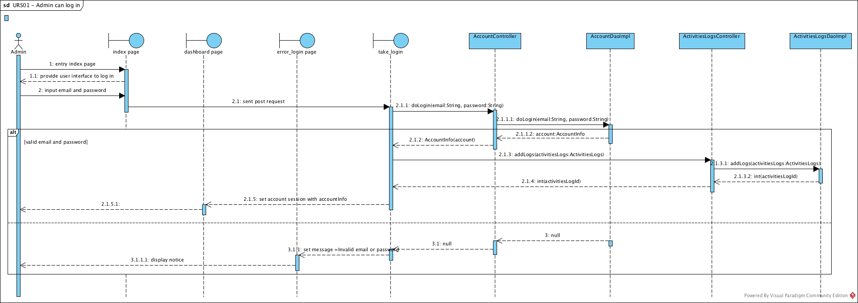

Figure 4.36: SD-01 Admin can login to web server sequence diagram

**SD-01** Admin can login to web server sequence diagram

### 3.3.2 URS-02: Admin can logout from web server

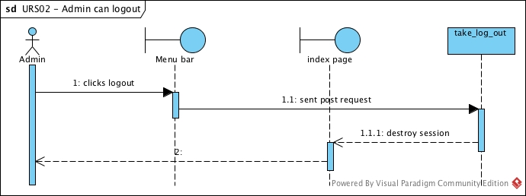

Figure 4.: SD-02 Admin can logout from web server sequence diagram

**SD-02** Admin can logout from web server sequence diagram

### 3.3.3 URS-03: Admin can add shop owner account

Figure 4.: SD-03 Admin can add shop owner account sequence diagram

**SD-03** Admin can add shop owner account sequence diagram

### 3.3.4 URS-04: Admin can edit shop owner account

Figure 4.: SD-04 Admin can edit shop owner account sequence diagram

**SD-04** Admin can edit shop owner account sequence diagram

### 3.3.5 URS-05: Admin can delete shop owner account

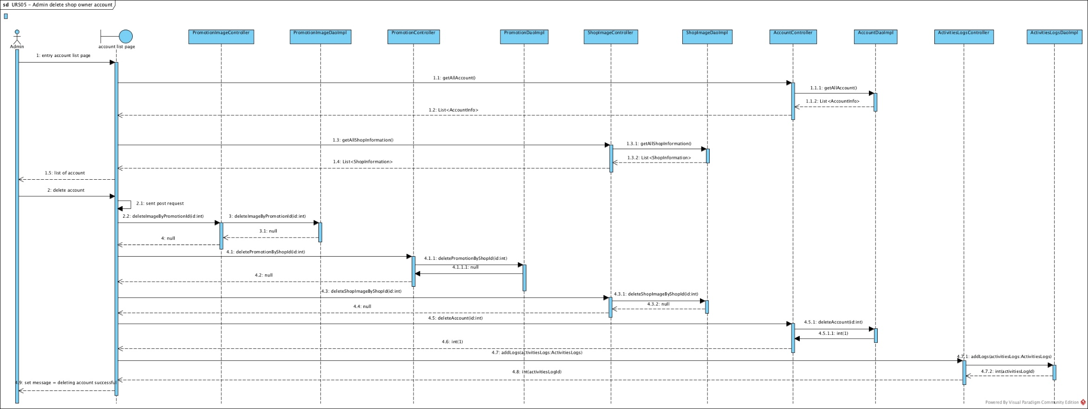

Figure 4.: SD-05 Admin can delete shop owner account sequence diagram

**SD-05** Admin can delete shop owner account sequence diagram

### 3.3.6 URS-06: Admin can add promotion to shop owner

Figure 4.: SD-06 Admin can add promotion to shop owner sequence diagram

**SD-06** Admin can add promotion to shop owner sequence diagram

### 3.3.7 URS-07: Admin can edit shop owner promotion

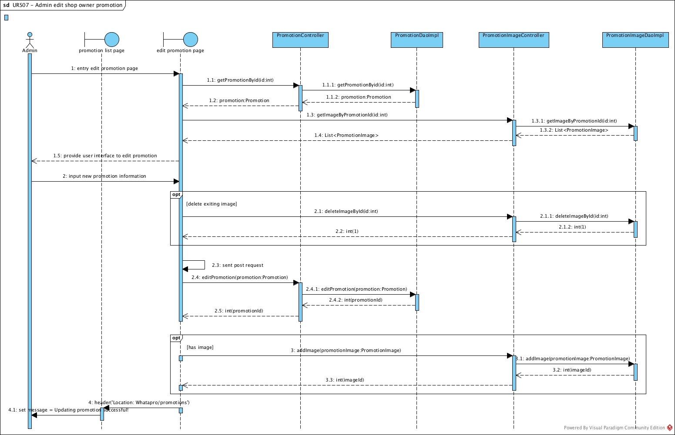

Figure 4. : SD-07 Admin can edit shop owner promotion sequence diagram

**SD-07** Admin can edit shop owner promotion sequence diagram

### 3.3.8 URS-08: Admin can delete shop owner promotion

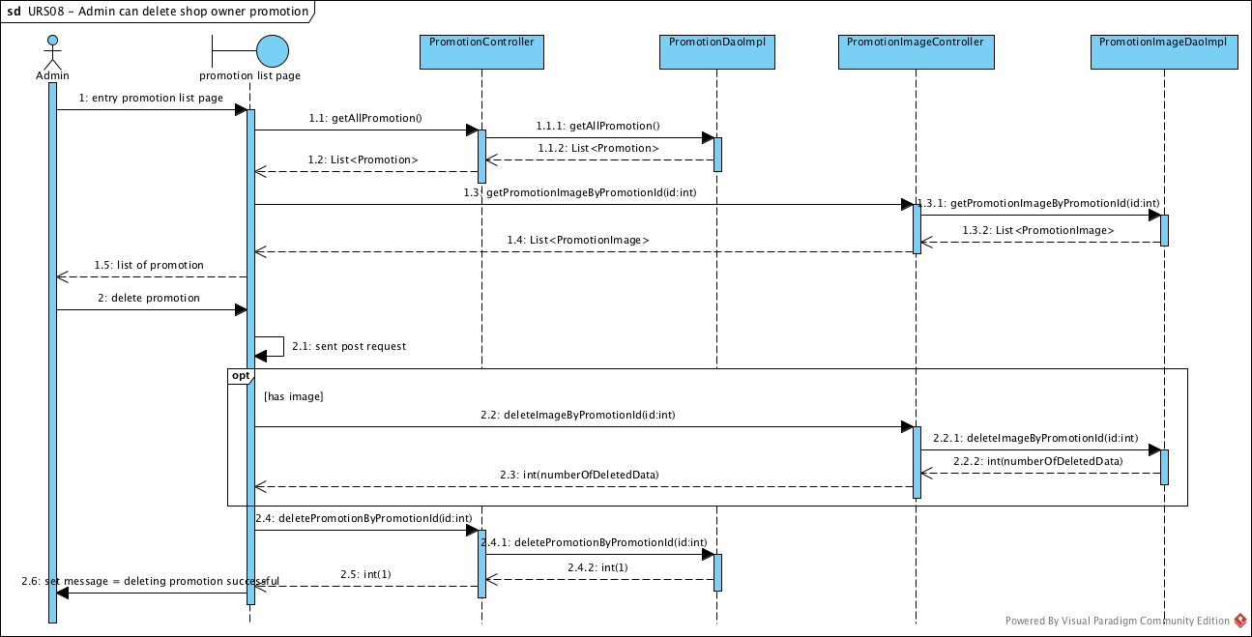

Figure 4.: SD-08 Admin can delete shop owner promotion sequence diagram

**SD-08** Admin can delete shop owner promotion sequence diagram

### 3.3.9 URS-09: Admin can accept register request

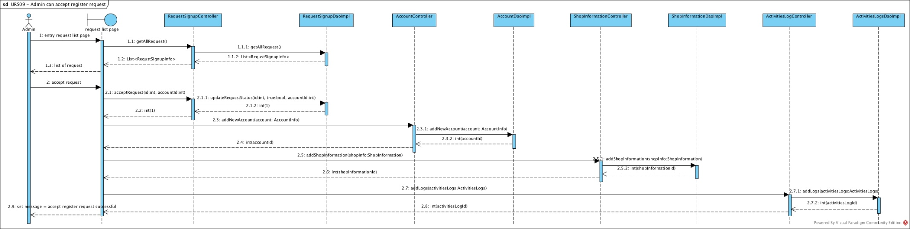

Figure 4.: SD-09 Admin can accept register request sequence diagram

**SD-09** Admin can accept register request sequence diagram

### 3.3.10 URS-10: Admin can reject register request

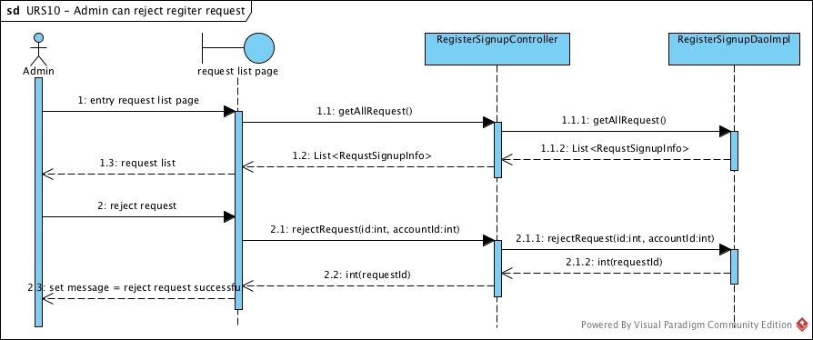

Figure 4.: SD-10 Admin can reject register request sequence diagram

**SD-10** Admin can reject register request sequence diagram

### 3.3.11 URS-11: Admin can view account list

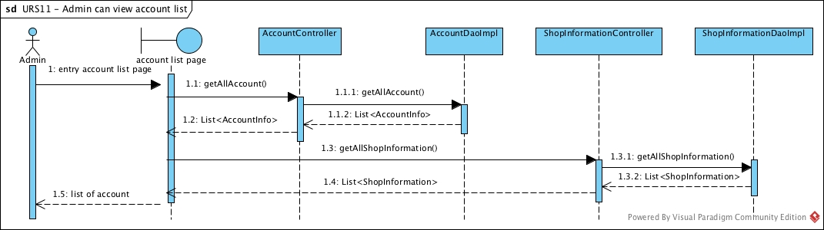

Figure 4.: SD-11 Admin can view account list sequence diagram

**SD-11** Admin can view account list sequence diagram

### 3.3.12 URS-12: Admin can view account information

Figure 4.: SD-12 Admin can view account information sequence diagram

**SD-12** Admin can view account information sequence diagram

### 3.3.13 URS-13: Admin can view promotion list

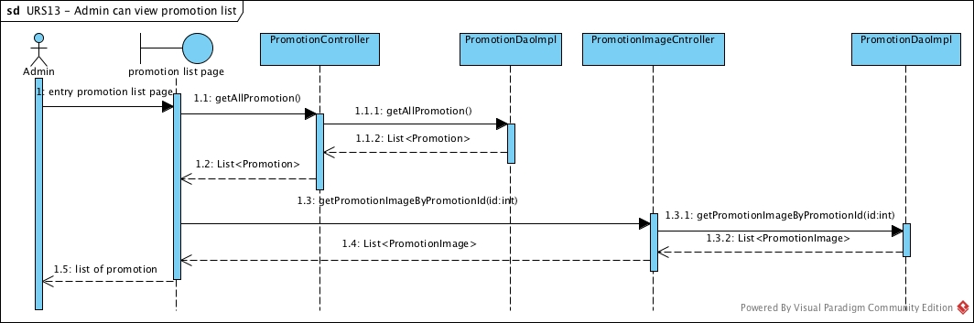

Figure 4.: SD-13 Admin can view promotion list sequence diagram

**SD-13** Admin can view promotion list sequence diagram

### 3.3.14 URS-14: Admin can view promotion information

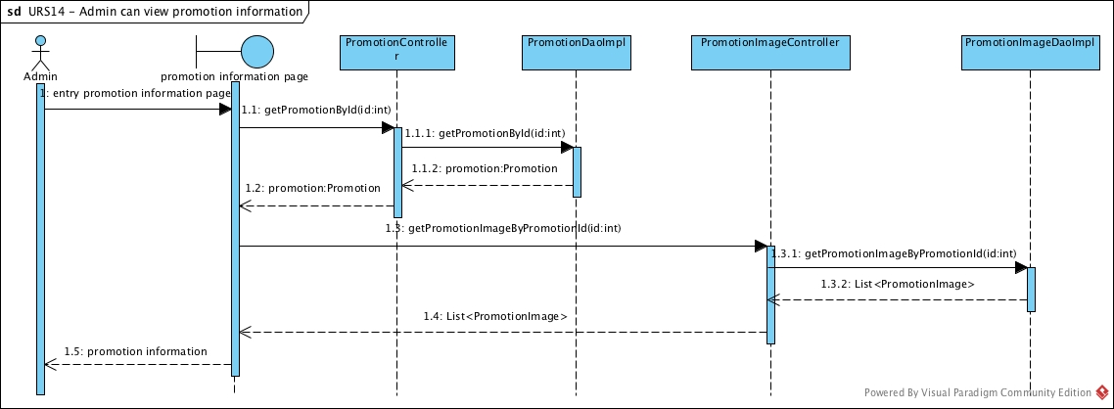

Figure 4.49: SD-14 Admin can view promotion information sequence diagram

**SD-14** Admin can view promotion information sequence diagram

### 3.3.16 URS-16: Admin can view redeem code list

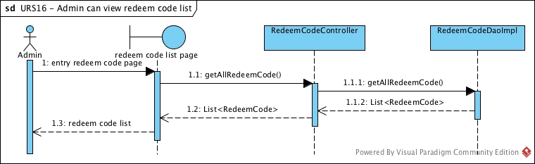

Figure 4.: SD-16 Admin can view redeem code list sequence diagram

**SD-16** Admin can view redeem code list sequence diagram

### 3.3.17 URS-17: Admin can view redeem code information

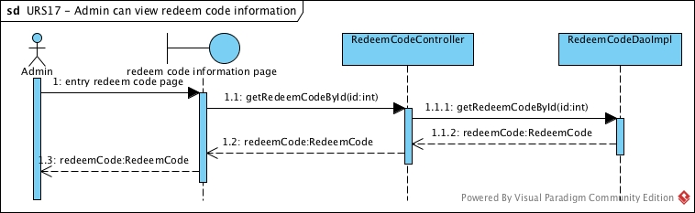

Figure 4.: SD-17 Admin can view redeem code information sequence diagram

**SD-17** Admin can view redeem code information sequence diagram

### 3.3.18 URS-18: Admin can view mobile user list

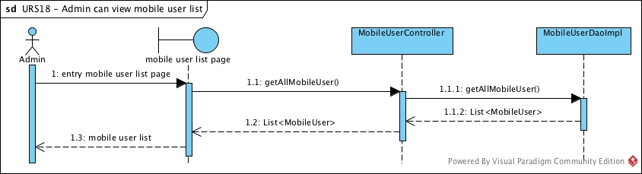

Figure 4.: SD-18 Admin can view mobile user list sequence diagram

**SD-18** Admin can view mobile user list sequence diagram

### 3.3.19 URS-19: Admin can view mobile user information

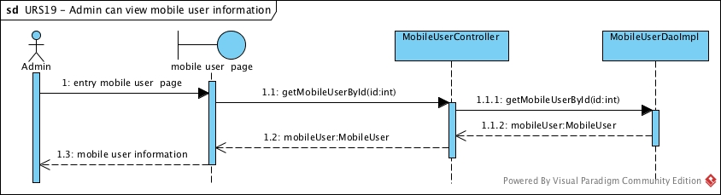

Figure 4.: SD-19 Admin can view mobile user information sequence diagram

**SD-19** Admin can view mobile user information sequence diagram

### 3.3.20 URS-20: Admin can search account by shop name

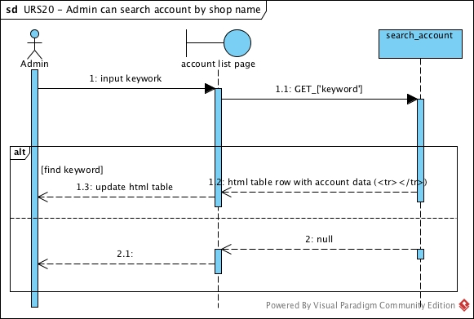

Figure 4.: SD-20 Admin can search account by shop name sequence diagram

**SD-20** Admin can search account by shop name sequence diagram

### 3.3.21 URS-21: Admin can search account by email

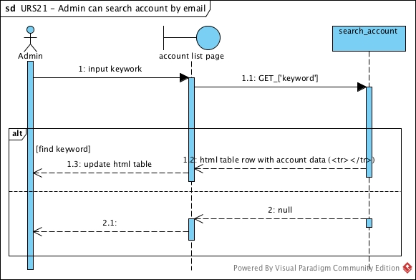

Figure 4.: SD-21 Admin can search account by email sequence diagram

**SD-21** Admin can search account by email sequence diagram

### 3.3.22 URS-22: Admin can search account by id

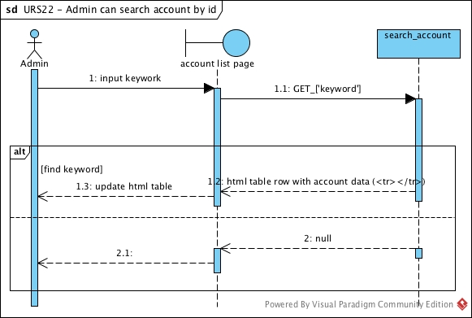

Figure 4.: SD-22 Admin can search account by id sequence diagram

**SD-22** Admin can search account by id sequence diagram

### 3.3.23 URS-23: Admin can search promotion by name

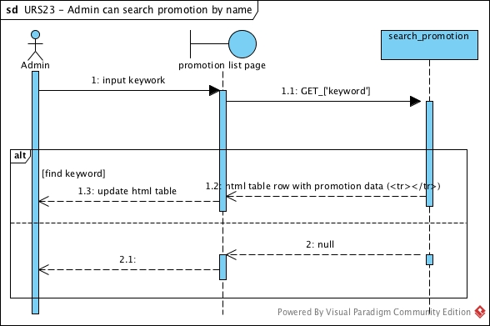

Figure 4.: SD-23 Admin can search promotion by name sequence diagram

**SD-23** Admin can search promotion by name sequence diagram

### 3.3.24 URS-24: Admin can search promotion by id

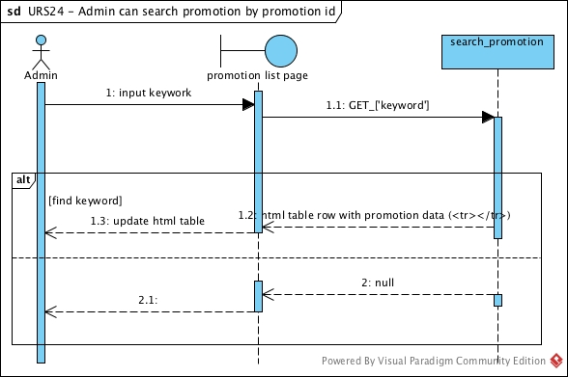

Figure 4.: SD-24 Admin can search promotion by id sequence diagram

**SD-24** Admin can search promotion by id sequence diagram

### 3.3.25 URS-25: Admin can search promotion by shop name

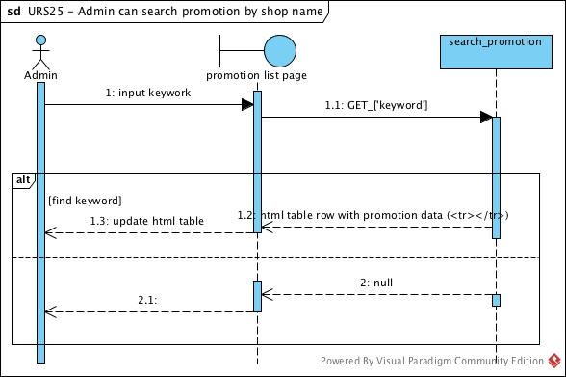

Figure 4.: SD-25 Admin can search promotion by shop name sequence diagram

**SD-25** Admin can search promotion by shop name sequence diagram

### 3.3.29 URS-29: Admin can change password

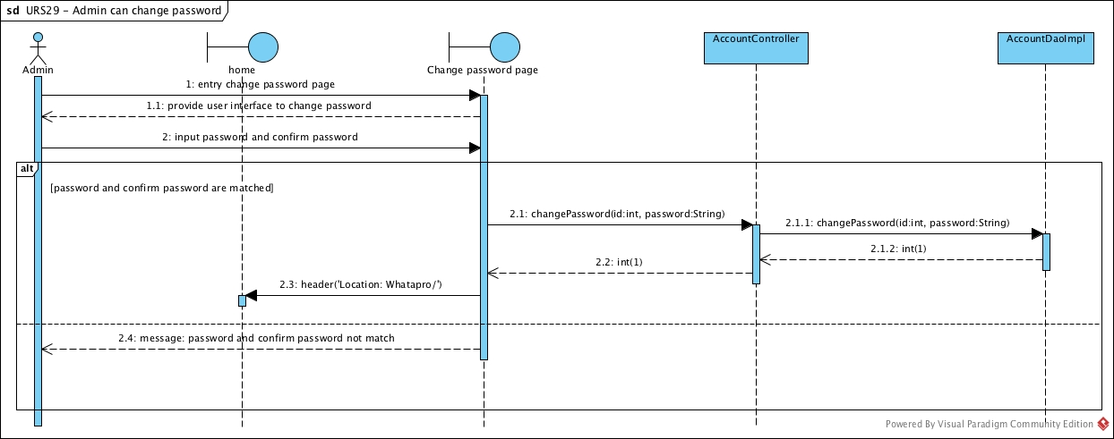

Figure 4.: SD-29 Admin can change password sequence diagram

**SD-29** Admin can change password sequence diagram

### 3.3.30 URS-30: Shop owner can add promotion

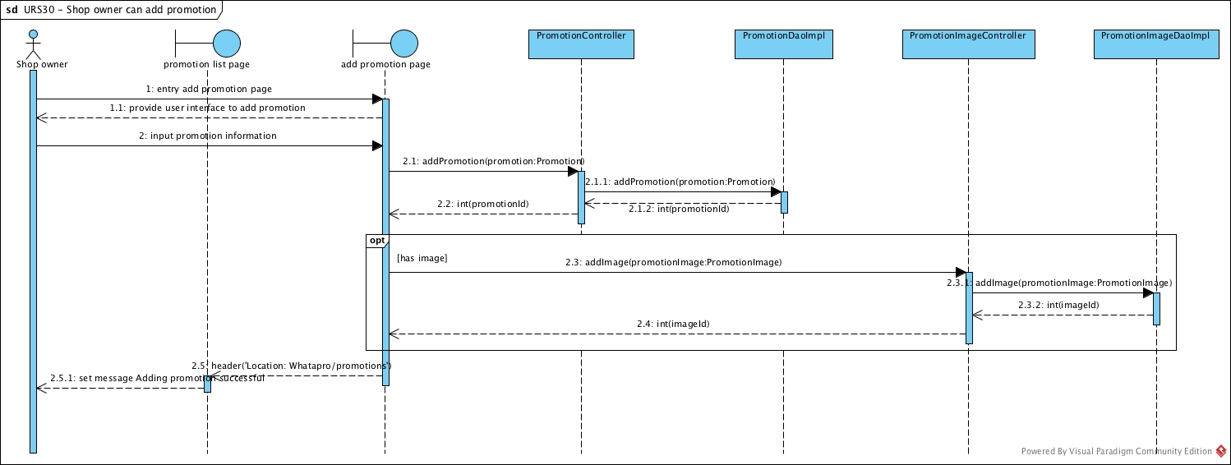

Figure 4.: SD-30 Shop owner can add promotion sequence diagram

**SD-30** Shop owner can add promotion sequence diagram

### 3.3.31 URS-31: Shop owner can edit promotion

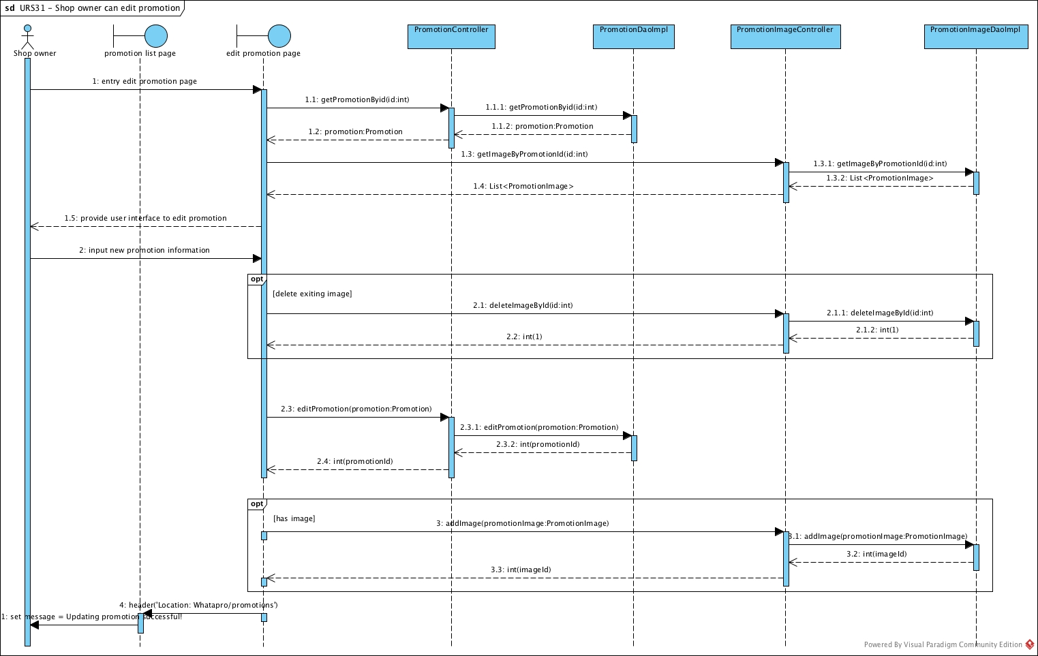

Figure 4.: SD-31 Shop owner can edit promotion sequence diagram

**SD-31** Shop owner can edit promotion sequence diagram

### 3.3.32 URS-32: Shop owner can delete promotion

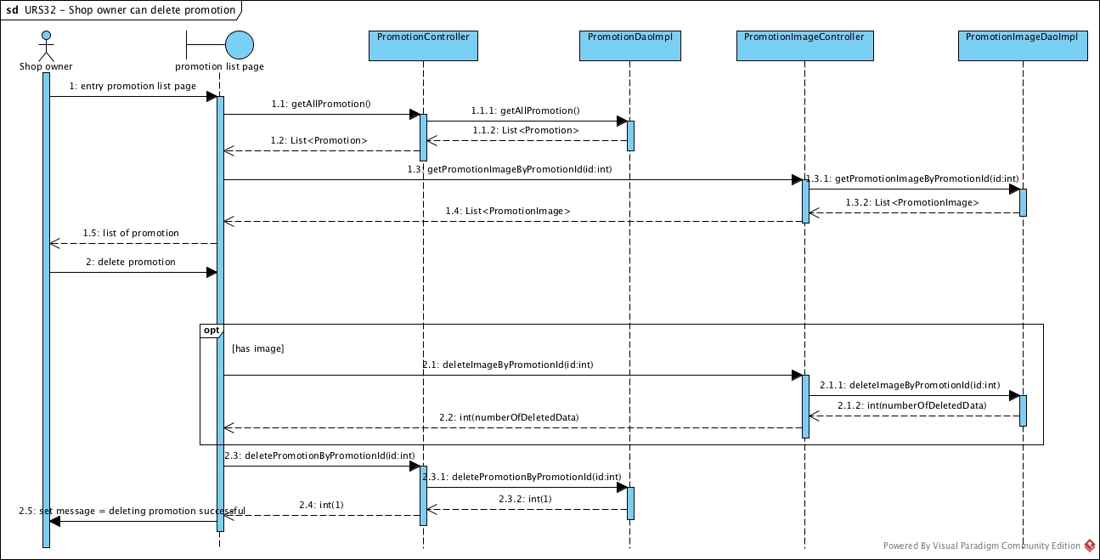

Figure 4.: SD-32 Shop owner can delete promotion sequence diagram

**SD-32** Shop owner can delete promotion sequence diagram

### 3.3.33 URS-33: Shop owner can update their profile

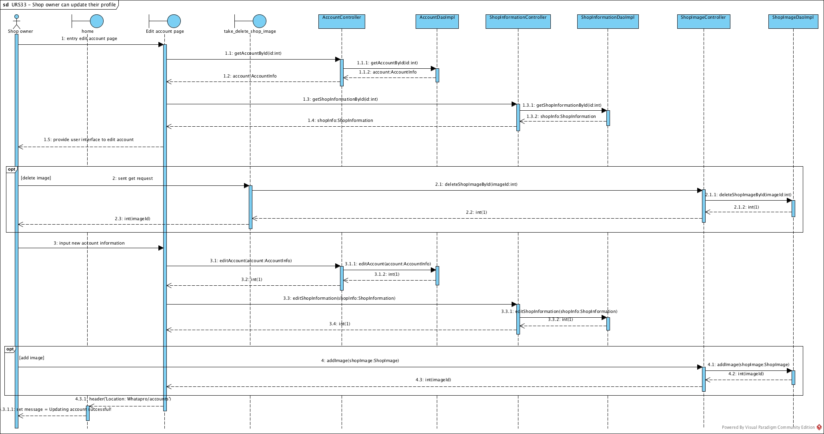

Figure 4.: SD-33 Shop owner can update their profile sequence diagram

**SD-33** Shop owner can update their profile sequence diagram

### 3.3.34 URS-34: Shop owner can change password

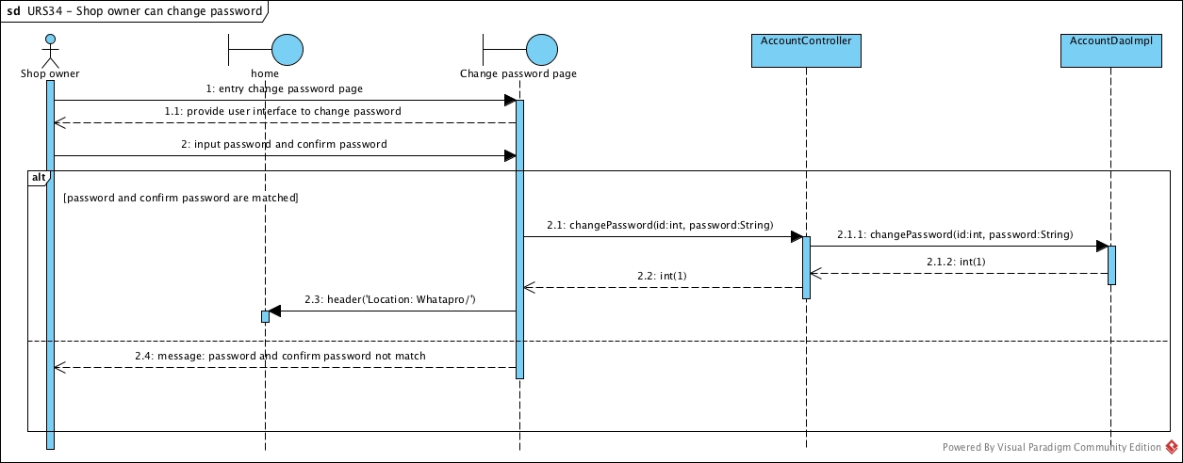

Figure 4.: SD-34 Shop owner can change password sequence diagram

**SD-34** Shop owner can change password sequence diagram

### 3.3.35 URS-35: Shop owner can login to system

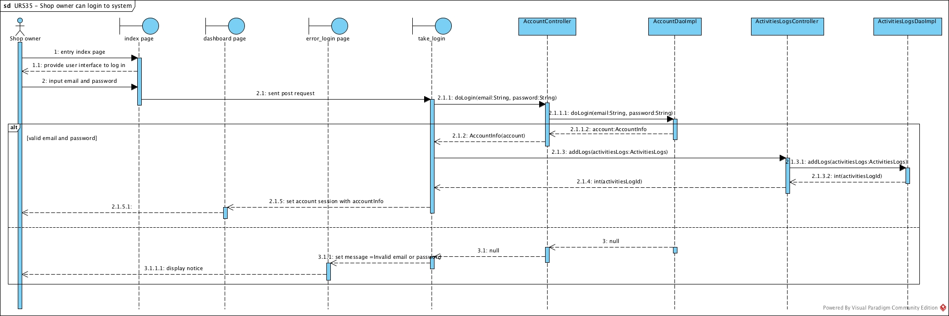

Figure 4.: SD-35 Shop owner can log in to system sequence diagram

**SD-35** Shop owner can log in to system sequence diagram

### 3.3.36 URS-36: Shop owner can logout

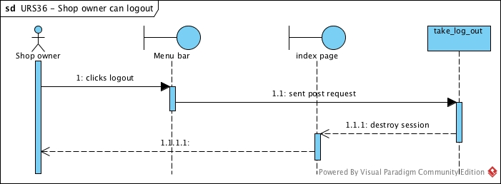

Figure 4.: SD-36 Shop owner can logout sequence diagram

**SD-36** Shop owner can logout sequence diagram

### 3.3.38 URS-38: Shop owner can view promotion list

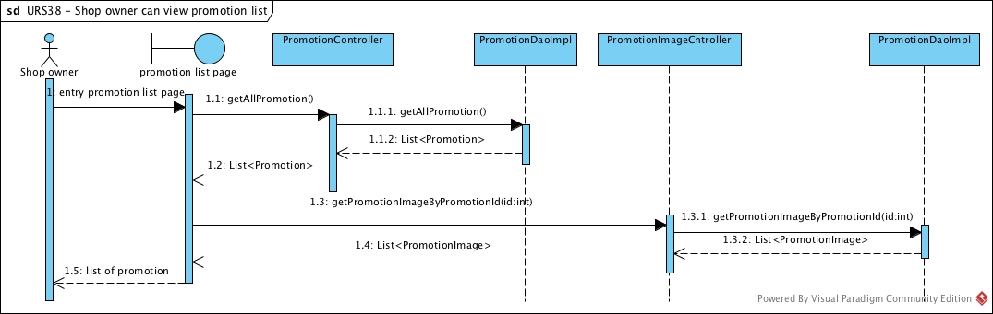

Figure 4.: SD-38 Shop owner can view promotion list sequence diagram

**SD-38** Shop owner can view promotion list sequence diagram

### 3.3.39 URS-39: Shop owner can view promotion information

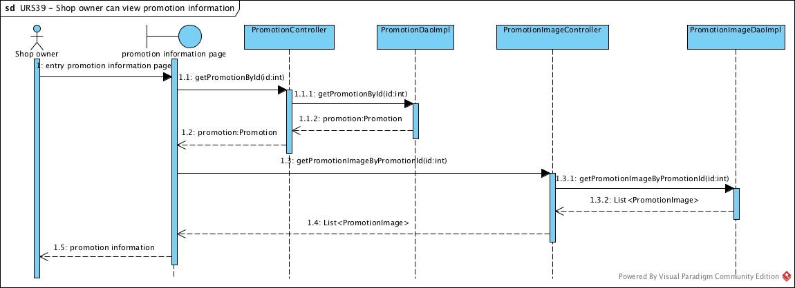

Figure 4.: SD-39 Shop owner can view promotion information sequence diagram

**SD-39** Shop owner can view promotion information sequence diagram

### 3.3.40 URS-40: Guest can sent register request

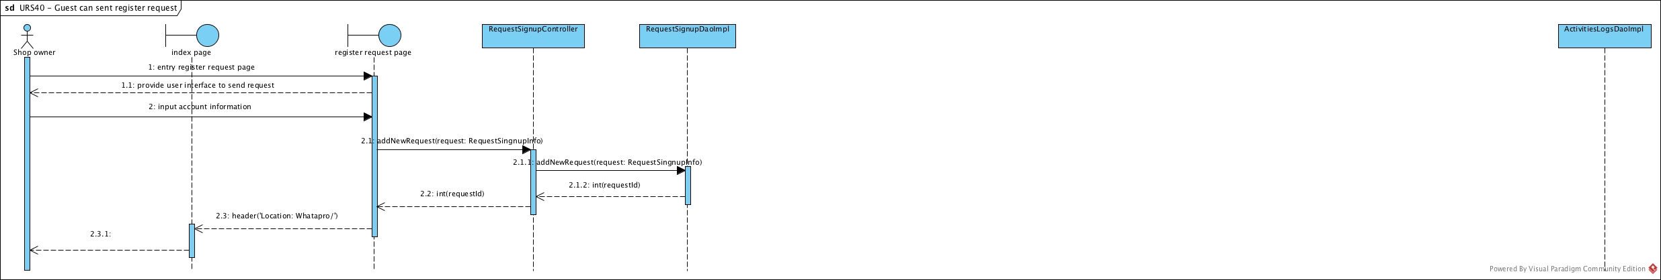

Figure 4.: SD-40 Guest can sent register request sequence diagram

**SD-40** Guest can sent register request sequence diagram

# Chapter 4 | User Interface Design

## 1. Index page

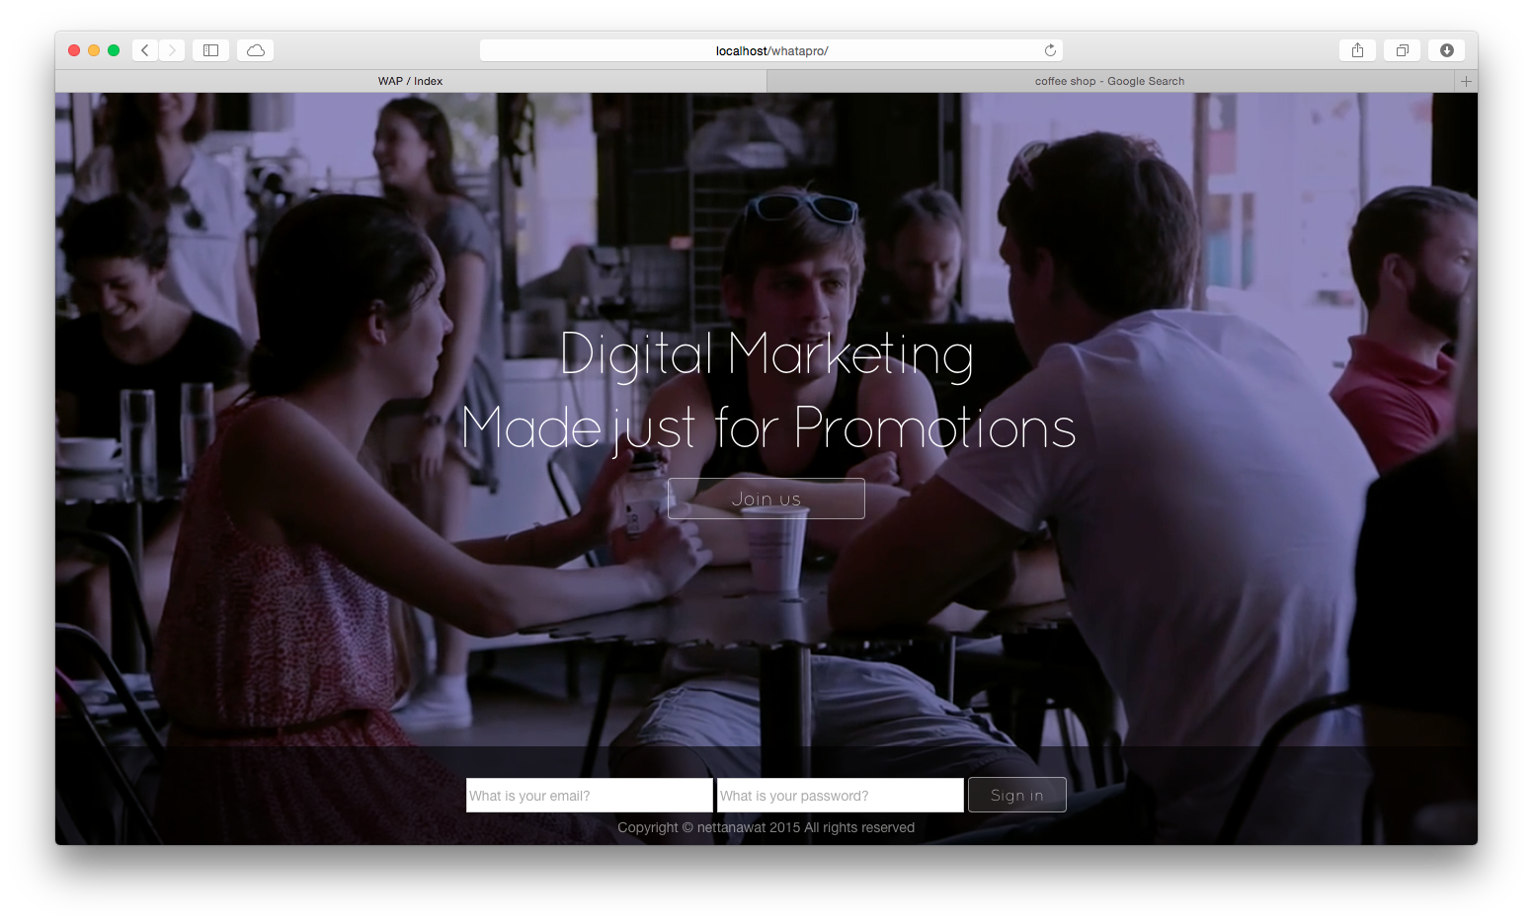

Figure 4.: Index page

This layout presented the main page of web service.

## 2. Promotion list page

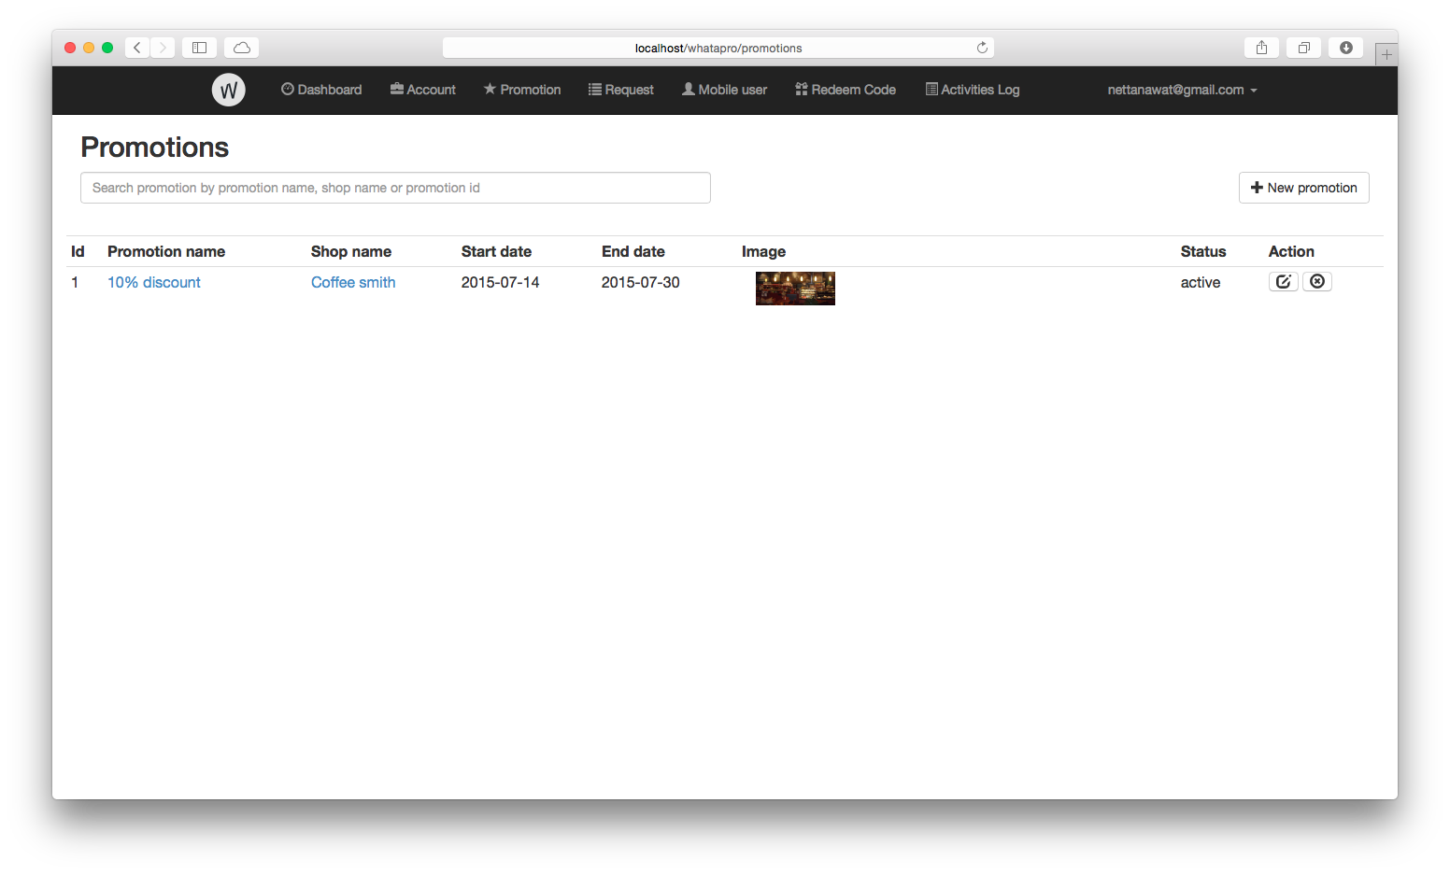

Figure 4.: Promotion list page

This layout presented the promotion page, allowing to add, edit, and delete promotion.

## 3. Account list page

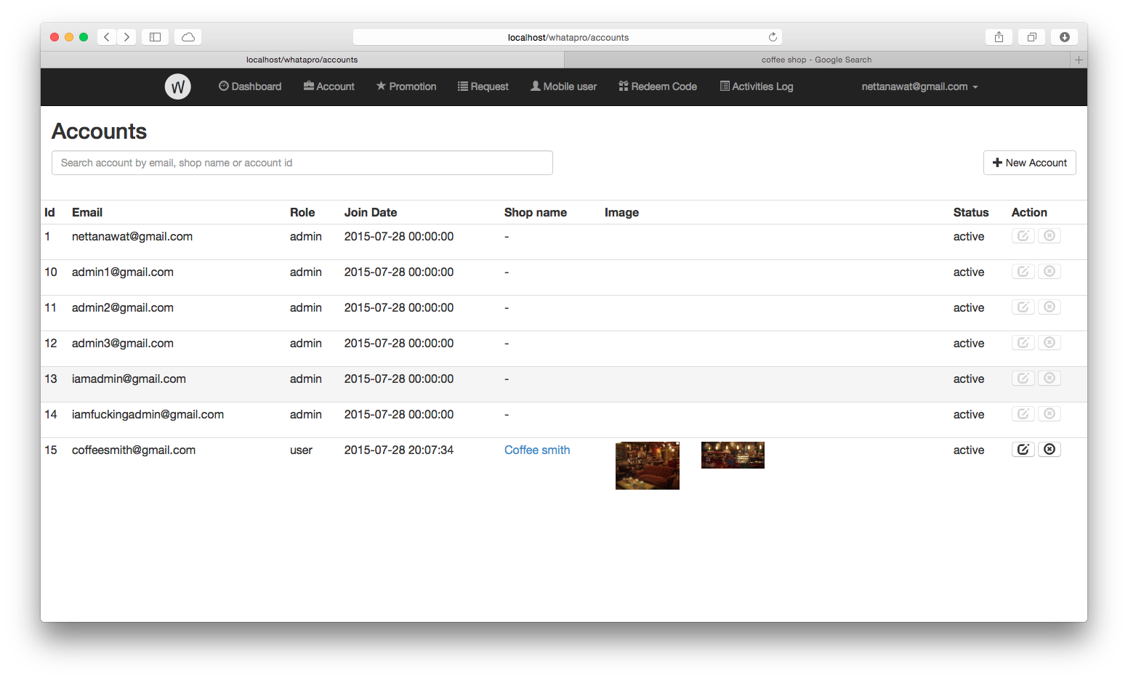

Figure 4.: Account list page

This layout presented the account page, allowing to add, edit, and delete account.

## 4. Request list page

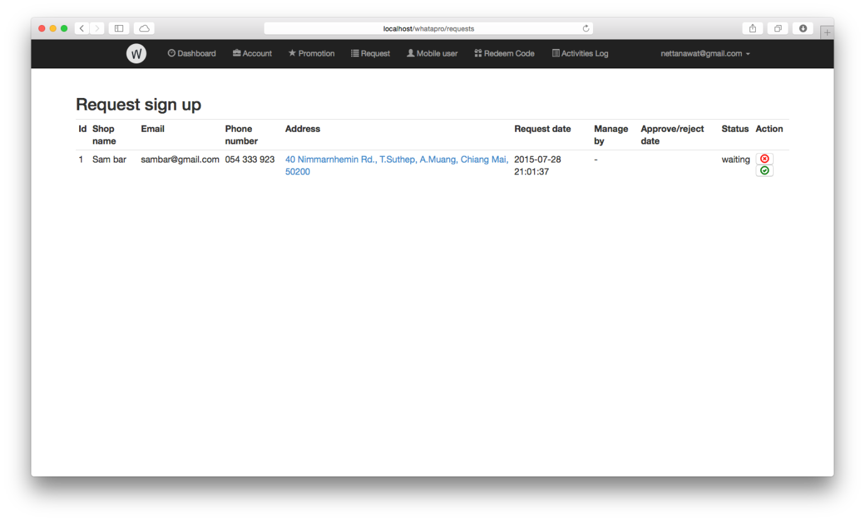

Figure 4.: Request list page

This layout is for admin to see request list and choose to accept or reject from this page.

## 5. Add promotion page

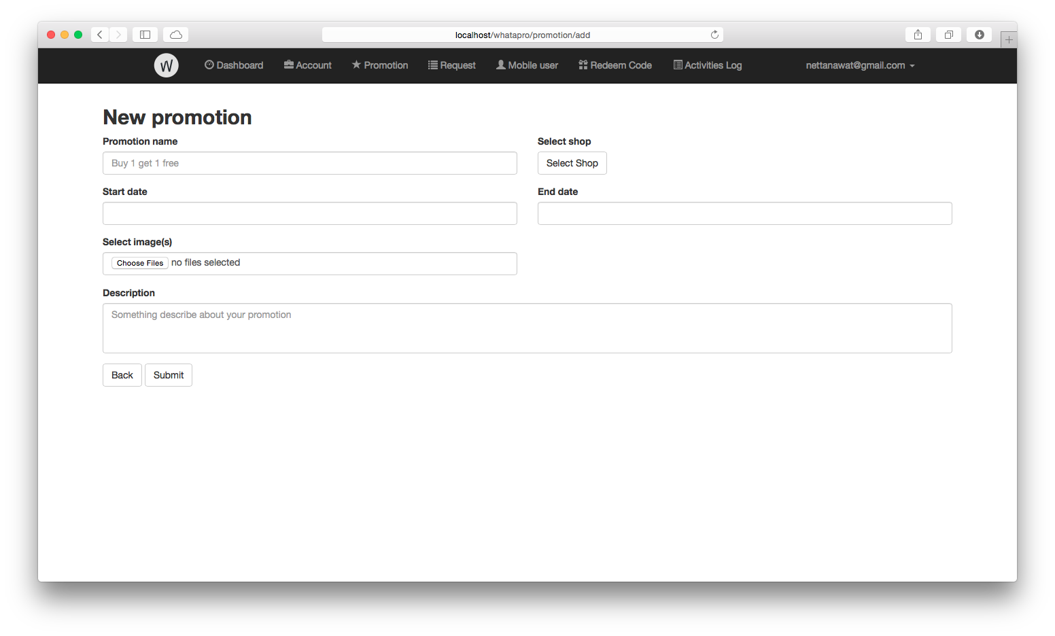

Figure 4.: Add promotion page

This layout is presenting an application form to add new promotion.

## 6. Add account page

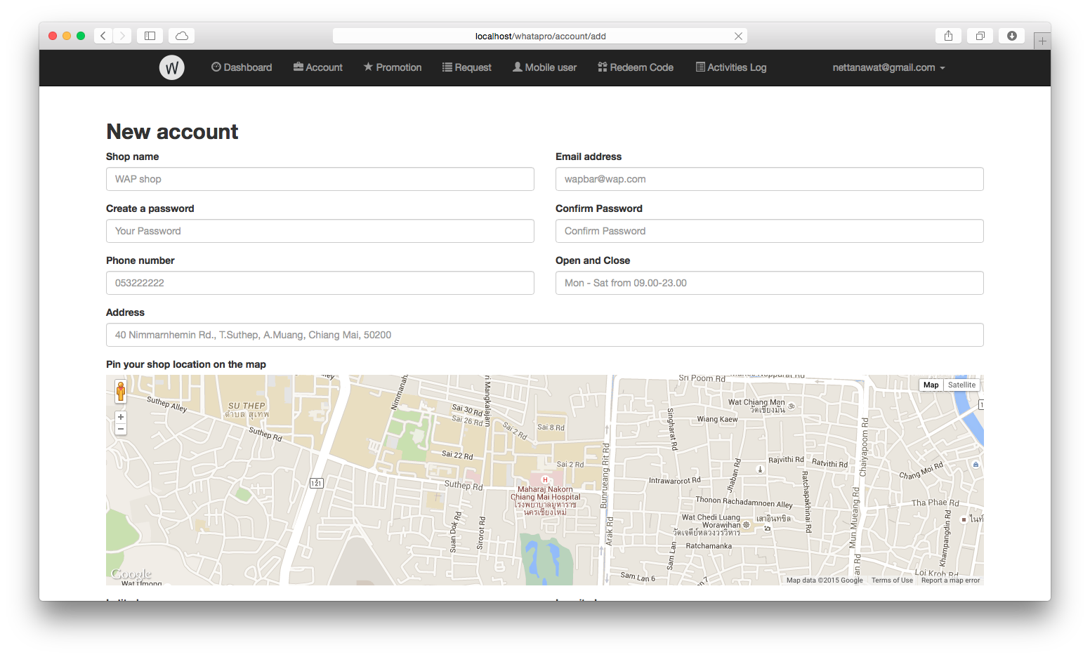

Figure 4.: Add account page

This layout is presenting an application form to add new account.

## 7. Promotion information page

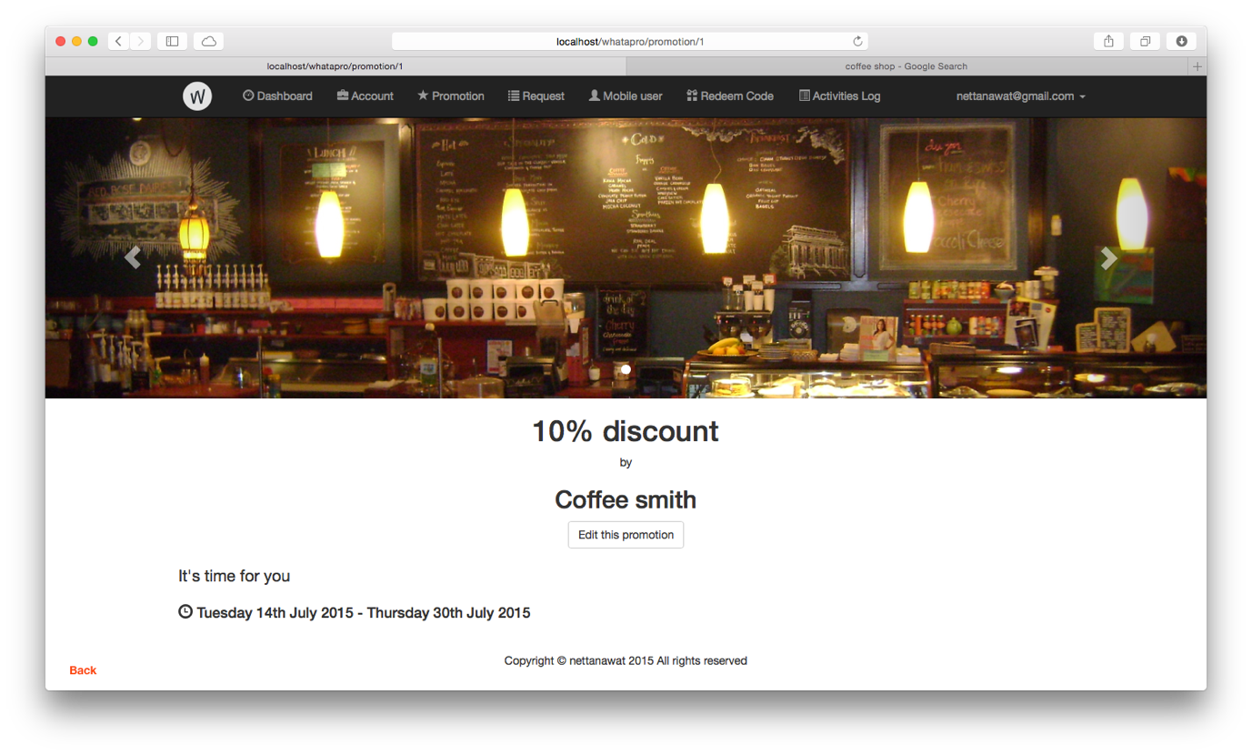

Figure 4.: Promotion information page

This layout is for view promotion information.

## 8. Account information page

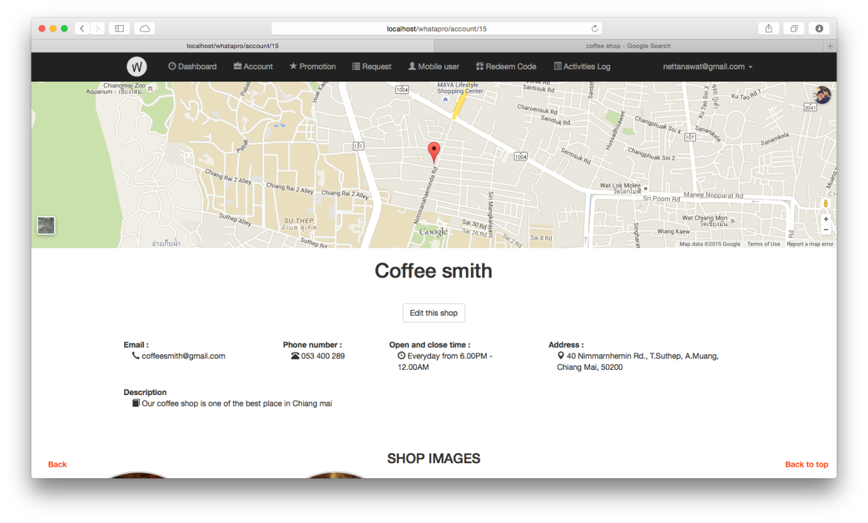

Figure 4.: Account information page

This layout is for view account information.

## 9. Home page

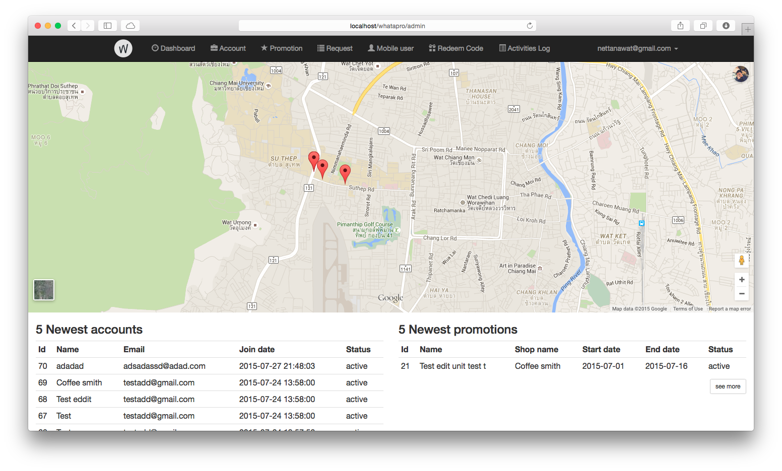

Figure 4.: Home page

This layout is home page for admin to view overall of system.